**Word Count: 12957**

**Emotion regulation strategy use and forecasting in response to dynamic, multimodal stimuli**

**William J. Mitchell a,** billy.mitchell@temple.edu **\***

**Joanne Stasiak b,** [joanne.stasiak@psych.ucsb.edu](mailto:joanne.stasiak@psych.ucsb.edu)

**Steven Martinez a,** [stevent.martinez@temple.edu](mailto:stevent.martinez@temple.edu)

**Katelyn Cliver c,** [katelyn.cliver@temple.edu](mailto:katelyn.cliver@temple.edu)

**David Gregory a,** [david.gregory@temple.edu](mailto:.gregory@temple.edu)

**Samantha Reisman d,** [Reisman@brown.edu](mailto:Reisman@brown.edu)

**Helen Schmidt a,** [helen_schmidt@temple.edu](mailto:helen_schmidt@temple.edu)

**Vishnu P. Murty a,** [vishnu.murty@temple.edu](mailto:.murty@temple.edu)

**Chelsea Helion a,** [chelsea.helion@temple.edu](mailto:chelsea.helion@temple.edu)

1. **Department of Psychology & Neuroscience**

Weiss Hall, Temple University, 1701 N 13th St. Philadelphia, PA, USA 19122

1. **Department of Psychological & Brain Sciences**

Building 251, University of California, Santa Barbara, Santa Barbara, CA, 93106

1. **Department of Psychological & Brain Sciences**

Disque Hall, Drexel University, 3201 Chestnut St, Philadelphia, PA 19104

1. **Department of Cognitive, Linguistic, and Psychological Sciences**

Box 1821, Brown University, Providence, RI, 02912

**\*** Corresponding author.

*E-mail address:* [billy.mitchell@temple.edu](mailto:billy.mitchell@temple.edu)

*Address:* 717 Weiss Hall, Temple University,

1701 N 13th St. Philadelphia, PA 19122

**ABSTRACT (250 / 250 Words):** Successful emotion regulation (ER) requires effective strategy selection. Research suggests that disengagement strategies (e.g., distraction) are more often selected than engagement strategies (e.g., reappraisal) as emotional experiences intensify. However, the extent to which ER strategy *choice* in controlled circumstances reflects strategy *usage* during complex, multimodal events is not well understood. The present research uses dynamic, multimodal stimuli (i.e., a haunted house, horror movies) to examine the association between affective intensity and regulatory strategy usage among untrained participants – individuals given no prior regulation instructions or direction. Both a preliminary study (n = 54) and Study 1 (*n =* 118) failed to find relationships between emotional intensity and strategy usage to downregulate emotions as participants navigated a haunted house. Contrary to expectations, the success of distraction decreased as emotional intensity increased in this context. Participants in Study 2 (*n* = 152) forecasted regulation strategy usage based upon descriptions of emotionally-regulated experiences from the preliminary haunted house study. Affective intensity predicted which strategies forecasters predicted they would use; though, forecasters overpredicted how often distraction was used in practice. Study 3 (*n* = 242) incorporated strategy usage and forecasting within the same design by showing untrained participants video stimuli of varying-intensity and capturing their regulatory responses. Forecasters again predicted using distraction more often than strategy users did in practice. Forecasters also overpredicted how effectively distraction reduced negative affective intensity relative to what strategy users reported. These results may highlight a disconnect between strategy fittedness while planning and executing self-regulation, especially in dynamic, complex settings.

**SIGNIFICANCE:** How individuals manage their emotions during dynamic, complex experiences is an important question for anxiety- and trauma-based disorder prevention and treatment. This study found distraction, but not reappraisal, to be less effective than anticipated as emotional intensity increases in these difficult-to-regulate environments, which contrasts findings from relatively less demanding contexts.

**CONSTRAINTS ON GENERALITY:** We aimed to generalize our findings to the downregulation of negative emotions by non-clinical US populations in dynamic, multimodal emotional situations. However, the setting of Study 1 (i.e., a haunted house) likely will not generalize to all dynamic, multimodal emotional situations. Studies 2 and 3 contain reasonably representative samples in terms of education, socioeconomic status, and race, but were collected online, thus limiting generalizability to non-optimal settings. Our recruitment added additional constraints as well. Using horror-related stimuli likely resulted in a self-selection bias. Participants in Study 1 skewed young, falling between the ages of 18 and 34, and were recruited from an urban setting, which may limit the applicability of our conclusions to children, older age groups, or individuals living in non-urban settings. Participants skewed more female than male in Studies 1 and 2 and more male than female in Study 3, which may result in an underrepresentation of men and women, respectively. Lastly, racial demographic information was not captured in Study 1, which leaves questions of racial representation unanswered. Future research should explore these phenomena in other novel settings with a wider age range and balanced gender ratio to enhance the external validity of our findings.

**KEYWORDS:** emotion, self-regulation, naturalistic stimuli, decision making

**INTRODUCTION**

Overwhelming situations can generate profoundly intense emotions which often do not match our ideal emotional states. We can try to change our emotional responses in loud or crowded spaces, unexpected confrontations, and circumstances that we lack control over, but our ability to successfully regulate our emotions in these situations may be limited. A key factor in determining regulation efficacy is the strategy someone uses or chooses. Regulation strategy efficacy can be highly context-dependent, leading many to emphasize studying emotion regulation (ER) in different contexts as the next crucial direction for the field (Aldao, 2013; Dixon-Gordon et al., 2015; English et al., 2017; Rottweiler et al., 2018; Tang & Huang, 2019).

**The Process Model of Emotion Regulation.** Foundational ER research (i.e., the Process Model) has identified categories of common strategies that people use to regulate their emotions (Gross, 1998). Characteristics of the regulator and the context can determine the effectiveness of these strategies (Young & Suri, 2020) and people often choose strategies to match their present circumstances (Opitz et al., 2015; Sheppes et al., 2011). For example, engagement strategies, like altering the meaning or interpretation of the emotion-eliciting stimulus (i.e., reappraisal), often have high cognitive demands. These can be contrasted against disengagement strategies, like diverting attention (i.e., distraction) or inhibiting the expression of emotion (i.e., suppression), which typically have relatively low cognitive demands (Sheppes & Gross, 2011).

How might these regulatory patterns be reflected in strategy choice? Although not explicitly directed to do so, the anticipation of a scary moment during a horror movie might prompt a person to look away from the screen (distraction), think about the actors in a different light (reappraisal), or limit the expression of their fear, all in an effort to reduce, or downregulate, an unwanted feeling. People in situations with few cognitive resources may compensate by selecting strategies that demand less cognitive effort according to the selection, optimization, and compensation (ER-SOC) hypothesis (Opitz et al., 2012). For example, if someone were watching a horror movie while they were tired or under high cognitive load, it may be easier to look away from the screen than to generate alternative, less fear-inducing reinterpretations by which to view the film’s events. Attempting to reappraise would constitute a high-risk strategy in this context because it might be less likely to work (Ford & Troy, 2019) than a comparatively low-effort strategy like distraction.

This supposition is bolstered by the especially robust influence of emotional intensity upon strategy choice, as distraction is chosen more often (Hay et al., 2015; Orejuela-Dávila et al., 2019; Sheppes et al., 2011; Young & Suri, 2020) and is more effective (Shafir et al., 2016) than reappraisal in response to high intensity stimuli, at least in part because it can be deployed before relevant emotional information has been represented in working memory (Sheppes et al., 2014; Sheppes & Gross, 2011) and requires fewer cognitive resources (Dorman Ilan et al., 2019). This effect has been thoroughly replicated in lab studies and ecological momentary assessment (EMA) studies (Colombo et al., 2020; Heiy & Cheavens, 2014). However, this association may not readily translate to more complex and demanding environments (Sheppes, 2020), like those which we test directly here, due to differences in how we commonly measure and manipulate ER in these studies.

**External Validity in Extant Emotion Regulation Paradigms.** Lab ER paradigms differ from the everyday experience of ER in a few key ways that may limit generalizability. Lab ER paradigms (e.g., Sheppes et al., 2011, 2014) usually train participants to use regulatory strategies before a task begins, which may prime more introspection and metacognition (Carver & Scheier, 1981) than what occurs in the typical ER experience. Lab ER paradigms also often necessarily show previews of emotional stimuli to allow participants to prepare their regulatory responses, but dynamic, high-intensity events in our everyday lives are often unexpected or difficult to anticipate. Following stimulus previews, lab ER paradigms also frequently prompt individuals to select a strategy, but aversive experiences in everyday life, like sharing the road with an erratic driver or being bullied, may not explicitly prompt the implementation of self-regulation.

Such study design decisions prioritize internal validity over external validity. Self-report capture of emotion in ER studies is often either assumed based upon standardized ratings associated with the stimuli (e.g., the IAPS picture set) (Bradley & Lang, 2007), measured through unidimensional Likert scales (e.g., valence) (Shafir et al., 2016), or is captured through established measures (e.g., the Positive and Negative Affect Schedule) (Watson et al., 1988; Weiss et al., 2021). These approaches offer an efficient, reliable, and standardized means of assessing self-regulation but make assumptions about the emotional states of subjects that might not accurately reflect the complexity of emotional experience. By relying upon these standardized manipulations, researchers are able to make a stronger casual claim regarding the relationship between emotion intensity and regulation, but at least one recent study found this relationship to be complicated when subjects’ emotional experiences were measured and not assumed (Specker et al., 2024).

(Friedman & Gustavson, 2022)

Contemporary constructivist theories posit that emotions are not fixed reactions but are instead shaped dynamically by cognitive and social processes, encompassing one’s personal interpretations, beliefs, and social interactions (Lindquist et al., 2012). Study designs that prioritize external validity promote participant- or stimulus-level idiosyncratic experiences that are pivotal to developing working generative models of how the world around us works (Lee et al., 2021). Free-response capture, more than discretely categorized self-reports or unipolar scales, may require fewer a priori assumptions from researchers about a participant’s emotional experience, thus reducing unintended researcher influence (Gendron et al., 2012; Lindquist et al., 2006) and improving generalizability (Miller et al., 2019). Applying natural language processing techniques to free-response data can improve our ability to capture the multifaceted, idiosyncratic emotional experiences that constructivist frameworks emphasize (Mohammad, 2018) without sacrificing accuracy (Diamond et al., 2020) or quantifiability.

Research designs that incorporate more features of naturalistic regulation, such as not instructing or prompting participants to regulate (e.g., Heiy & Cheavens, 2014; Opitz et al., 2015) often find people explore and flexibly apply multiple strategies that blur the boundaries of typical strategy classifications (Aldao & Nolen-Hoeksema, 2013; Ford et al., 2019; Heiy & Cheavens, 2014; Opitz et al., 2015; Szasz et al., 2018). These approaches also capture meaningful variance in self-regulatory behaviors that more controlled designs cannot (Friedman & Gustavson, 2022; Kamradt et al., 2014; Malanchini et al., 2019). For example, overstimulation from complex, multimodal contexts may simultaneously be aversive and more cognitively demanding (i.e., better suited for disengagement strategies). However, attention may also be challenging to control in a context with so much attention-demanding stimuli, reducing the likelihood of observing the high-intensity-distraction association characterized in laboratory studies (Draheim et al., 2022). Spontaneous or untrained ER in these contexts may rely more heavily on person-specific features like habits than how emotionally arousing the situation may be (Christou-Champi et al., 2015; Koole et al., 2015; Norem, 2008). Yet, challenging situations may be precisely when adaptive regulatory control (i.e., the pattern between intensity and regulation choice observed in most laboratory studies) may be most valuable, as maladaptive ER tendencies predict more severe manifestations of post-traumatic stress disorders (Hannan & Orcutt, 2020) and related post-traumatic stress disorder outcomes (Specker & Nickerson, 2022). Thus, identifying whether the established association between intensity and effort-related strategy usage occurs in high stress contexts is important for the development of potential interventions.

**The Present Study.** To our knowledge, no study has examined whether affective intensity predicts strategy usage in aversive, high-intensity, multimodal contexts using untrained participants (i.e., individuals given no prior training in how to use or classify ER strategies and no explicit direction to regulate their experiences). While affective intensity represents a particularly prominent predictor of ER behavior (i.e., *r+* = 0.46 – 0.61; “a very large effect size”, according to recent meta-analyses; Matthews et al., 2021), the extent to which features of a dynamic, multimodal situation could overshadow this effect remain unclear. The goal of the present research is to examine whether these well-established regulatory patterns emerge in samples of untrained participants exposed to a dynamic, feature-rich stimuli high in emotional variability, such as a haunted house. Haunted house experiences have been used with marked success in recent research to study emotion and self-regulation (Clasen et al., 2019; Stasiak et al., 2023; Tashjian et al., 2022). While haunted houses only represent a small proportion of the variability which emotionally-relevant experiences could materialize as, they nonetheless offer safe and controlled but high-arousal events to elicit a wide range of emotional experiences (i.e., positive and negative emotions), intensities, and responses (i.e., regulation behaviors). This variance would be difficult to generate in a complex multimodal context outside of the lab while offering the same level of safety to the participants and control to the researchers.

Because the comparison between reappraisal and distraction is nearly ubiquitous in the extant regulation literature, as noted by Heiy & Cheavens (2014), Study 1 aimed to test whether this effect extends to untrained subjects in high-intensity circumstances by having untrained participants navigate a haunted house and report their undirected emotional and regulatory behaviors in a surprise recall task immediately after and one week after exposure. This granted high levels of fidelity in capturing subjective participant emotion and experience at the expense of experimental control. We additionally anticipated that participants experiencing high cognitive load as a result of exposure would more often use distraction, in line with the ER-SOC hypothesis. Surprisingly, we did not find that intensity or cognitive load predicted strategy usage. To minimize researcher bias, we then applied a multiverse approach to the data, systematically expanding and constraining our data inclusion criteria and adjusting for important covariates such as regulation tendencies and emotional goals, in an effort to identify conditions in which the relationship between affective intensity and strategy usage might emerge as statistically significant. We again failed to find an association.

This surprising finding motivated Study 2, which aimed to determine whether participants exposed to similar experiences as the haunted house but in a less dynamic, lower-intensity context (i.e., forecasting rather than experiencing) would more often forecast, or predict, using distraction in response to descriptions of high intensity regulated events and reappraisal in response to descriptions of low intensity regulated events from the haunted house. We hypothesized that the decontextualized self-regulation choices motivated by stimulus-response paradigms might be closer in practice to simulating or forecasting self-regulation than regulation usage. We did observe the canonical association between emotional intensity and regulatory strategy selection with this design, though with an effect size smaller than the typical range found by Matthews et al. (2021). However, many study design differences between Studies 1 and 2 limited our ability to draw conclusions about why those differences in outcome may have occurred.

To attempt to close this design difference gap, Study 3 tasked untrained participants with watching videos of varying negative intensity and subsequently either reporting the regulatory strategies that they used (strategy usage) or the strategies that they predict might be used (strategy forecasting) to downregulate their negative emotions. For both forecasters and strategy users, increasing self-reported affective intensity predicted a greater likelihood of using distraction. However, forecasters were less likely than regulators to use reappraisal at low intensities. A trend that emerged across all three studies was an inconsistency between how effective participants predicted distraction might be within these situations and how effective distraction was actually reported to be. Methods and analyses supporting these findings are discussed.

**STUDY 1 METHODS**

Study 1 tested whether the emotional intensity of negatively-valenced events was associated with the likelihood of using a low-effort or high-effort regulatory strategy in a dynamic, feature-rich setting with an untrained sample of participants. To assess emotional intensity, participants performed a surprise free recall task immediately after exposure during which they self-reported the emotions they experienced via free-response and the intensity of those emotions during self-selected events from the haunted house. Participants also noted the direction of their regulation attempts (i.e., upregulation, downregulation, no regulation), how effective those regulation attempts were, and the means by which they attempted to regulate in their own words. We report how we determined our sample size, all data exclusions, all manipulations, and all measures in the study.

**PARTICIPANTS:**

**Preliminary Study.** A preliminary study was conducted in October 2019 consisting of 54 participants (age: *x̄ age* = 24.22 yrs, range = 18 – 34 yrs, *sd age* = 3.97 yrs; gender: 26 female, 27 male, 1 non-binary; Ethnicity: 18.51% Hispanic, 81.49% Not Hispanic) who were recruited from a large northeastern city via flyers for an IRB-approved fear and memory study. This study aimed to characterize the memory of (Cliver et al., 2024) and physiological responses to (Stasiak et al., 2023) high-intensity, naturalistic events. However, this preliminary study was also designed to allow us to determine the distribution of ER strategy usage in this context and determine a more appropriate sample size for our primary study, as a review of the extant literature did not yield analogous study designs within the ER space. *A priori* power analyses for this preliminary study were conducted using the smallest effect size reported by Sheppes et al.’s 2011 examination of emotional intensity and regulatory choice (*ηp2* = 0.43). Using “WebPower” (Zhang & Mai, 2019) in R 3.6.1 (R Core Team, 2022), we determined 18 participants would sufficiently power our main effect in a typical lab context. Given the additional complications our study design introduces which would likely reduce the effect size between our variables of interest and the resources we had available, we surmised a sample of 54 participants, three times the minimum sample size, might be sufficient to identify an effect. This analysis failed to find a statistically significant association between affective intensity and strategy usage, but our best performing multilevel binary logistic regression model [*strategy ~ intensity + (1 | Participant)*], as determined by an AIC comparison information theoretic approach, produced an odds ratio of *OR* = 1.83 (*95% CI* = [0.65, 3.2], *p* = 0.079) (*See* **Supplementary Materials** for more preliminary study design and analyses details). This observed model from the preliminary study was used to generated an *a priori* power curve for Study 1 via “simr” (Green & MacLeod, 2016) in R 3.6.1, which estimates the proportion of simulated datasets in which the null hypothesis is rejected given the target model. This approach to calculating power is preferrable for hierarchically-structured data because it does not assume independence of observations. We determined that at least 76 participants with an average of 3 observations each (228 observations total) would be required to sufficiently power our study based upon simulations with the observed data (Two-tailed, α = 0.05, 1–β= 0.80, *Pr(Y =1|X=1)* *H0* = 0.615). We increased the target sample size to 120 participants, due to attrition concerns and the needs of the concurrently-ran experiment on fear and memory (Cliver et al., 2024). However, we were only able to recruit 98.33% of our recruitment goal due to time constraints (i.e., all data collection must occur before the haunted house closes for the season).

**Study 1.** In October 2021, 118 participants (age: *x̄ age* = 20.80 yrs, *range* = 18 – 34 yrs, *sd age* = 2.87 yrs; gender: 73 female, 40 male, 5 non-binary) were recruited from a large northeastern city via flyers for an IRB-approved study on fear processing at a local haunted house attraction. A description of Study 1’s design is illustrated in **Figure 1**. Eligible participants were native English speakers between the ages of 18 and 35, had normal or corrected-to-normal vision, were not pregnant, had no history of seizures, cardiovascular issues, or neurological disorders, could comfortably walk for at least one hour, and had not been to this haunted house in the past. On average, participants were more educated (*x̄ Years of Education* = 16.90 yrs, *sd Years of Education* = 2.75 yrs) than the average US adult, who according the U.S. Census Bureau’s American Community Survey, has completed 13.7 years of education. Categorically, 81.9% reported having completed some college (58.6%), a 4-year degree (12.9%), some post-graduate studies (03.4%), or a post-graduate degree (06.9%). Socioeconomic status was slightly negatively skewed, with 14.5% of respondents reporting making less than $15,000 per year, 07.7% reporting between $15,001 and $25,000, 07.7% reporting $25,001 to $35,000, 05.1% reporting between $35,001 and $50,000, 22.2% reporting between $50,001 and $75,000, 12.8% reporting between $75,001 and $100,000, 17.9% reporting between $100,001 and $150,000, and 12.0% reporting greater than $150,000. The racial and ethnic identities of participants were not assessed. Participants were compensated $60.00 in Visa debit cards.

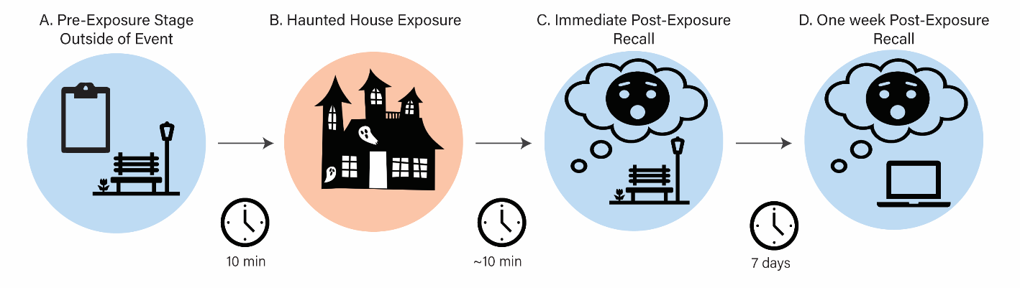

**Fig 1.** Study 1: Task Overview - One hundred and eighteen (118) participants traversed a haunted house in small groups. (**A**) Prior to the haunted house, participants completed baseline questionnaires outside of the event at a local park. (**B**) The haunted house lasted for ~37 minutes. (**C**) Participants then immediately recalled three events, and their attempts to regulate them post exposure. (**D**) They then again recalled the same three events and an additional six events at an online follow-up session.

**MATERIALS AND PROCEDURE:**

**Pre-Exposure**. Participants reported to a provisional headquarters (i.e., tent, tables, chairs, computers, etc.) constructed just outside the haunted house property to complete individual difference questionnaires, questionnaires assessing prior knowledge of the haunted house, expectations, and motivations for participating, as well as a measure of cognitive load. To assess prior knowledge, participants indicated the number of times they had attended other haunted houses, how much information they felt they knew about this specific haunted house, and from which sources had they learned information about this specific haunted house (e.g., advertisements, friends, news reports, etc.). To assess expectations, participants were asked how much positive and negative emotion they anticipated experiencing prior to exposure on a 5-point Likert scale. Labels for the 5-point Likert scales included “None at all”, “A little”, “A moderate amount”, “A lot”, and “A great deal”. Participants were also asked how fearful they felt, how sensitive they were to startling stimuli, how much they enjoy haunted houses, and how much they enjoy feeling fear (all assessed on Likert scales). Motivations to participate were assessed using 100-point sliding scales and included payment, thrills, novel experiences, challenges, social pressure, scientific interest or duty, and boredom. The poles and central position were labelled as “Not at all motivating”, “Moderately motivating”, and “Extremely motivating”. Cognitive load was assessed prior to exposure, immediately after exposure and at a later follow-up using a 15-item Remote Associates Test (RAT). Forty-five RAT items were selected for their difficulty as measured by Bowden’s 15-second trials, such that each item had two equally difficult counterparts which could be randomly assigned across the three timepoints (Bowden & Jung-Beeman, 2003). Following instructions, participants completed three practice trials with feedback. During the RAT task, participants had 15 seconds to identify the target word and did not receive feedback. Participants were then fitted with heartrate monitors and escorted to the haunted house entrance. All pre-exposure questionnaires and materials are available within our OSF repository (*See* **Open Practices**).

**Exposure (Haunted House).** Participants experienced the haunted house in 31 groups across 11 nights (*x̄ size* = 3.81 participants; *sd* size = 1.12 participants). This specific haunted house was chosen because: 1) it uses professional actors renowned for eliciting a range of affective responses; 2) it contained four themed sections designed to be either low- or high-intensity, each with a unique aesthetic providing variability to the stimuli; 3) it provides a remarkably consistent experience across sessions; and 4) coordination with the facility granted us special privileges to use equipment (i.e., computers, heart-rate monitors) and better guarantee consistency across exposures (i.e., entering before other guests, keeping groups together).

Participants received minimal instructions to promote ecological validity. Participants were to walk through the haunted house in a single file line and avoid sharing thoughts, reactions, and experiences with other participants. Limiting communication prevented participants from skewing each other’s memories and perceptions of the events before they could be recorded. Participants were encouraged to act and react as naturally as possible without interacting with each other (i.e., grabbing, holding, touching, etc.). While verbal and physical social support are recognized and effective forms of emotion regulation, they were beyond the purview of this study’s focus, which was based upon common Process Model strategies. However, perceptions of social support were captured after exposure to assess their potential effect upon our outcomes of interest. As part of a concurrently-run memory experiment, some participants (*n =* 58) did receive additional instruction to navigate specific sections as if they would later have to complete a memory test or write a review of that section. However, these groups did not statistically differ significantly from the control group in reported affective intensity (*F*(2,81) = 1.41, *p* = 0.25), regulation strategy usage (*F*(2,73) = 0.05, *p* = 0.95), or regulation strategy success (*F*(2,81) = 1.93, *p* = 0.15) as determined by ANOVA. The data relevant to this memory experiment is beyond the purview of this study and is better captured within another forthcoming manuscript. The accompanying research assistant led the group through each section. The approximate exposure time was 37.4 minutes.

**Post-Exposure.** Following exposure, participants completed immediate post-exposure assessments at a remote site outside of the haunted house. Participants were tasked with identifying three emotionally salient events that occurred from a randomly selected haunted house section and reporting affective and regulatory details of that event. Events from other haunted house sections were not tested during the immediate exposure session to avoid conflicts with the aforementioned concurrently-running memory experiment. Participants were not trained in ER strategies, nor were they primed to consider their ER strategies prior to these questionnaires. Though experiential sampling methods (ESM) and ecological momentary assessments (EMA) are often applied in naturalistic settings to capture moment-to-moment fluctuations in emotion and regulation with considerable success (*See* Colombo et al., 2020; Shahane et al., 2023), we chose post-exposure assessments as our means of assessment in part for the following reasons: 1) assessing participant reactivity mid-exposure can lead participants to alter their affective and regulatory behaviors in response to the assessment prompts (Stone et al., 2003), 2) training participants to use ESM or EMA technology effectively in this context would require training in ER strategy categorization in violation of the goals of this study, and 3) the use of such technology during exposure would violate the immersive, high-intensity nature of the context (Shiffman et al., 2008). Furthermore, studies which have used cued recalls to capture ratings of emotion experiences after exposure have found high consistency between experience and recall (Hutcherson et al., 2005; Levenson et al., 1983). For each of the three events, participants wrote a detailed description of what occurred. Participants then noted which emotions (up to a total of five) they felt during this event via free response. Participants rated how intense their emotion felt ("During [this event], how intense was the [emotion] you experienced?") on a 5-point Likert scale (labels included, in order of increasing intensity: ‘None at all’, ‘A little’, ‘A moderate amount’, ‘A lot’, and ‘A great deal’). Participants were also tasked with describing how they tried to regulate each emotion, if at all ("Did you attempt to reduce or intensify this [emotion]?"), via free response (“Please describe how you attempted to reduce or intensify this [emotion]”). People’s accuracy in recalling details of similar real-world experiences via free response was surprisingly high in recent investigations using similar methodology (Diamond et al., 2020). Participants were also asked directly whether they attempted to down- or up-regulate their experiences, how successful their regulatory efforts were, and regulatory responses were assessed in response to each emotion rather than each event. Thus, rather than exploring this phenomenon at the event-level, which might require regressing the probability of using a strategy upon the average intensity of all emotions experienced in that event – an assumption we would not make in confidence – we draw associations between regulation strategy usage and the emotions that participants identify as directly motivating them. We refer to data captured at this time point as being “immediately reported”. Following completion of immediate post-exposure measures, participants were dismissed, instructed to not discuss their experiences, and to remain in contact with researchers for a follow-up session which was conducted remotely (*time since exposure: x̄ delay* = 7.01 days; *sd delay* = 0.91 days) to assess how memory of self-regulation and memory accuracy in this context alters over time. At this delayed follow-up session, participants were tasked with identifying six additional events and their affective and regulatory responses to each.

**Strategy Usage Coding**. During the preliminary study, two hypotheses-blind raters classified strategy descriptions into one or more strategy categories: Reappraisal, Distraction, Suppression, Situation Selection, Situation Modification, or ‘None of the above’ (IRR Agreement = 0.880). Raters were also provided the participant’s description of the event and the emotions they experienced which they indicated having downregulated. Raters were undergraduate research assistants who trained by first reviewing examples of landmark literature which defined the strategies of interest as commonly used in the field (Gross, 1998, 2002). Raters then reviewed select methodological excerpts from experimental papers to see how cognitive reappraisal, attention deployment, and other Process Model strategies were defined within past studies (Shafir et al., 2016; Sheppes et al., 2011). Lastly, raters independently completed classification exercises using examples of regulation strategy descriptions from the same context but which were collected during the preliminary study. Through the training and classification process, raters were instructed not to collaborate or discuss their ratings with each other during the rating process. After individually classifying each description, a moderator (author W.M.) compared the ratings for disagreements (i.e., cases in which raters disagreed on how a regulation event should be classified). The moderator then met with both raters remotely using a digital video conferencing platform and moderated a review of the classifications, asking raters to compromise in cases of classification disagreement. The moderator’s role was to facilitate discussion of classifications and document their conclusions, but was not involved in the discussion and disconnected during them (i.e., muted their microphone; turned off camera) to avoid unduly influencing the outcome.

This approach revealed that distraction and reappraisal were by far the most commonly used strategies in this context. Of the 182 self-reported downregulated events recorded in the preliminary study, 30.7% used reappraisal and 61.5% used distraction, with the other three strategies (i.e., suppression, situation modification, situation selection) combined appearing in fewer than 20% of events (Note that the total percentage sum is greater than 100% due to the occurrence of multi-strategy experiences). Two hypotheses-blind raters classified each observation’s strategy description in Study 1 into one or more strategy categories: Reappraisal, Distraction, Suppression, a combination of the three, or none of the above (IRR Agreement = 0.877). Situation Modification and Selection were excluded due to the infrequency of their use. Suppression was also used infrequently in Study 1, but was categorized by Study 1 raters due to its large presence within the broader literature. Raters were undergraduate research assistants who were trained using the same methodology described in the preliminary study, but were not the same raters from the preliminary study. The training materials and instructions generated for this purpose have been made available within our OSF repository (*See* **Open Practices**).

**Event Location Coding.** Prior to launching our study, a key was generated by research staff documenting all of the unique events contained within the haunted house, including descriptions, temporal order, and the approximate locations of each event. This key was used as a reference by two additional hypothesis-blind independent raters who had not experienced the haunted house to identify the approximate locations of each event reported by participants using the detailed descriptions that they provided. Each event was labeled as occurring either within one of the four sections or as “not applicable” in cases of high ambiguity. The training and rating process otherwise mirrored the procedure outlined for strategy usage coding. Agreement between raters was high (IRR = 0.918).

**Questionnaire response processing and coding**. Emotion responses were processed by: 1) removing entries lacking intelligible affective information (e.g., “-“, “nothing”, “idk man”), 2) removing unnecessary punctuation, hyphenation, and qualitative modifiers (e.g., “very sad” becomes “sad”, 3) splitting compound emotion response (e.g., “sad / angry” becomes “sad” and “angry”, 4) correcting spelling errors according to the top suggestions recommended by R’s native spell checking software, 5) lemmatization (e.g., “annoyance”, “annoying”, and “annoyed” become “annoy”). These modified emotion responses were then merged with the NRC lexicon which contains over 20,000 English emotion words human rated by valence, arousal, and dominance (Mohammad, 2018). Valence was determined using NRC lexicon valence scores. Observations without an associated NRC lexicon entry were dropped due to lack of valence data.

**Analysis.** To explore our primary question, the effect of emotional intensity upon regulatory strategy usage, we specified mixed effect binary logistic regressions accounting for the random effect of participants using the “lme4” package (Bates et al., 2015) in R (R Core Team, 2022) and followed an information theoretic approach via AIC comparison, which prioritizes model parsimony and penalizes models with excessive variables.

This observational approach, using the idiosyncratic self-reported emotional intensity of each subject to predict regulation behaviors, differs substantively from its experimentally-controlled predecessors, which generally instead manipulate emotion using standardized stimuli sets and use the standardized intensity of each stimulus as the predictor of strategy choice rather than the intensity subjects actually experienced. Such an approach assumes that, over a sufficiently large sample, the average experienced intensity of any given stimulus will match the standardized value for that stimulus. In exchange for making this assumption, researchers likely reduce potential confounds and are better able to address causality. By not making the same assumptions as more experimentally controlled studies, our analytic approach seeks a pragmatic understanding of the relationship between intensity and emotion regulation, accepting potential confounds as they may naturally cooccur and aiming to determine whether the relationship exists despite the typical, everyday variability in emotion responses that standardized approaches smooth over.

All data and scripts used to produce this analysis are publicly available at OSF (*See* **Open Practices**). Preregistration for Study 1 methods and hypotheses is publicly available at As Predicted (https://aspredicted.org/DP1_453).

**STUDY 1 RESULTS**

A subset of 298 observations in which a negative emotion was downregulated by either distraction or reappraisal was used for analyses related to our primary hypothesis. These observations were reported by 77 participants. Of the 298 total observations, 175 (58.72%) reported using distraction to regulate their emotions. The average emotional intensity of observations was 2.41 (*range* = 0 – 4, *sd* = 0.932). **Figure 2b** illustrates the variance in all emotions and **Figure 2a** illustrates the emotions endorsed within the dataset of 298 observations.

**Thrill-seeking motivated study participation.** Although horror attractions may feature aspects of emotional experiences that are difficult to capture in more traditional paradigms, they may have limitations as well. For example, such a setting may generate self-selection biases in our sample. To monitor this, participants were asked about their expectations and motivations to participate in this study. Participants were asked how much they enjoyed fear on a 0 to 6 scale, with the average response sitting above the midpoint of the scale (*x̄* = 3.40, *median* = 4, *sd* = 1.82). Participants were also asked, “To what extent are the following items motivating your participation?” on a 0 to 100 scale with items including: the payment received for participating (*x̄* = 59.2, *median* = 59, *sd* = 31.1), the thrills they may feel in the haunted house (*x̄* = 63.3, *median* = 73, *sd* = 31.7), the opportunity for new experiences (*x̄* = 70.1, *median* = 78, *sd* = 28.0), the opportunity for challenging experiences (*x̄* = 53.3, *median* = 50, *sd* = 30.3), social pressures (*x̄* = 15.5, *median* = 02, *sd* = 25.7), a desire to help science (*x̄* = 59.4, *median* = 58, *sd* = 29.9), and boredom (*x̄* = 28.0, *median* = 15, *sd* = 31.4). Thrill-seeking motivations strongly correlated with fear enjoyment (*r* = 0.582, *p* < 0.001) and Bonferroni-adjusted contrasts did determine that thrill-seeking as a motivation was significantly greater than boredom (*t*(144) = 7.17, *p* < 0.001), social pressure (*t*(144) = 9.70, *p* < 0.001), and the pooled average of all motivations (*t*(504) = 4.19, *p* < 0.001), but not challenge-seeking (*t*(144) = 2.05, *p* =0.289), novelty-seeking (*t*(144) = -1.38, *p* = 1.000), payment (*t*(144) = 0.84, *p* = 1.000), or science participation (*t*(144) = 0.81, *p* = 1.000). This may suggest that our participants were slightly higher in thrill-seeking motivations relative to what we might expect to find in an average population.



**Fig 2.** Frequency-weighted word clouds illustrating: **(A)** allemotions endorsed during Study 1 and **(B)** all negatively-valenced emotions which were downregulated using either reappraisal or distraction during Study 1. The size of the term positively correlates with the frequency with which it was self-reported by participants.

1. **B.**

**Study participants regulated their emotions without prompt.** Another limitation may be a lack of motivation to self-regulate. Because haunted houses are entertainment, participants may be less inclined to self-regulate, regardless of which strategy they use. Within the preliminary study, we found a positive association between state anxiety measured immediately before the haunted house and the average extent to which participants attempted to regulate their emotions (assessed through the question, “To what extent did you attempt to change or regulate how you felt during this event?”) across events (*β* = 0.34, *95% CI* = [0.054, 0.626], *p* = 0.021), as well as a positive association between the average negative affective intensity of an event and extent to which participants attempted to regulate their emotions during that event (*β* = 0.31, *95% CI* = [0.17, 0.46], *p* < 0.001) (*See* **Supplementary Materials** for more preliminary study design and analyses details). Both suggest, as expected, that participants within this setting experiencing negative emotions do self-regulate these emotions without researcher-prompting. Self-regulation extent or efforts were not assessed within Study 1 to reassess this relationship.

**Intensity did not predict regulatory strategy usage.** To test our primary hypotheses, models using either z-scored emotional intensity or person-centered emotional intensity as the primary predictor were constructed iteratively (i.e., adding one fixed effect to the model at a time), but across all model comparisons, no model performed better than our null model which did not feature any fixed effects (*ICC* = 0.40). Our best performing non-null model -- including only intensity as a fixed effect (*p* = 0.10 when compared to null) -- did not find a relationship between emotional intensity and strategy usage (*OR* = 1.36, *95% CI* = [0.95, 1.95], *p* = 0.10) (**Fig. 3**). An odds ratio of 1.36 suggests that for every one standard deviation unit increase in emotional intensity, the odds of choosing distraction to regulate increase by approximately 36%, but importantly, this association is not statistically significant and markedly smaller than what might be observed in more controlled strategy selection paradigms. As such, we did not find strong evidence to support that emotional intensity predicts strategy usage in this dynamic, high-intensity situation.

**Fig 3.** Across almost all tested mixed effects binary logistic regression models, emotional intensity failed to predict strategy usage. Visualized is our model using only emotional intensity (*x̄* = 2.41, *sd* = 0.932) to predict regulation strategy choice between reappraisal and distraction among negative emotions. Regression line represents likelihood of selecting distraction as opposed to reappraisal at any given emotional intensity value. Points represent individual observations. Regression ribbon represents standard error.



**Cognitive load did not predict regulatory strategy usage.** The association between strategy choice and cognitive load has been well documented in the literature (Dorman Ilan et al., 2019), but attempts to replicate it beyond lab settings have been limited. Given the high-intensity, often overwhelming nature of this setting, we had preregistered the hypothesis that cognitive load should demonstrate a positive association with the probability of using distraction as an ER strategy. However, we failed to find evidence that cognitive load post-exposure -- as assessed by the RAT test – predicted strategy usage during exposure (*b* = - 0.02, *95% CI =* [-0.044, 0.010], *p* = 0.21), even when adjusting for baseline cognitive load as assessed both prior to exposure and one-week later.

**Nuisance variables did not predict regulatory strategy usage.** In addition to our primary analyses, we evaluated the impact of several nuisance variables. These are variables that, according to existing research, might confound the relationship between affective intensity and strategy usage, but were not of primary theoretical focus for these experiments. Examples measured in this study include emotion expectations (Denny et al., 2014), motivations to participate (Tamir, 2016), attitudes towards fear and haunted houses (Argyriou & Lee, 2020), participant sex (McRae et al., 2008), age (Blanchard-Fields et al., 2004), depression (BDI-II), anxiety (STAI), intolerance of uncertainty (IUS) (Aldao et al., 2010), regulation tendencies (ERQ) (Gross & John, 2003), time of day, and presence of peers.

We did not find significant associations between the proportion of events in which distraction was used and how positively (*b* = 0.035, *95% CI =* [-0.032, 0.102], *p* = 0.30) or negatively (*b* = 0.047, *95% CI =* [-0.017, 0.112], *p* = 0.14) participants expected to feel during the study. We also did not find an association between distraction versus reappraisal usage and the motivations cited for participation, including payment (*b =* -0.000, *95% CI =*[-0.003, 0.002 ], *p =* 0.629), thrill-seeking (*b =* -0.000, *95% CI =*[-0.003, 0.002], *p =* 0.801), novelty-seeking (*b =* 0.001, *95% CI =*[-0.002, 0.004], *p =* 0.454), peer influence (*b =* 0.001, *95% CI =*[ -0.002, 0.003], *p =* 0.595), boredom (*b =* -0.001, *95% CI =*[ -0.004, 0.001], *p =* 0.341), contributing to science (*b =* 0.000, *95% CI =*[-0.002, 0.002], *p =* 0.858), and seeking a challenge (*b =* 0.000, *95% CI =*[ -0.003, 0.002], *p =* 0.935). We additionally did not find any associations between distraction usage and how much participants self-reported enjoying fear (*b =* -0.012, *95% CI =*[-0.050, 0.027], *p =* 0.55) or haunted houses (*b =* 0.021, *95% CI =*[ -0.024, 0.066], *p =* 0.35), participant sex (t(73) = 1.54, *95% CI =*[ -0.029, 0.225], *p =* 0.13), age (*b =* 0.000, *95% CI =*[-0.024, 0.023], *p =* 0.98), depression (*b =* -0.004, *95% CI =*[-0.024, 0.016], *p =* 0.70), anxiety (*b =* 0.000, *95% CI =*[-0.009, 0.008], *p =* 0.97), intolerance of uncertainty (*b =* 0.000, *95% CI =*[-0.005, 0.006], *p =* 0.92), tendency to use reappraisal (*b =* 0.000, *95% CI =*[-0.012, 0.013], *p =* 0.97) or suppression (*b =* 0.002, *95% CI =*[-0.011, 0.015], *p =* 0.76), time of day (*F*(2,73) = 0.04, *p =* 0.96), presence of familiar peers (*t*(60) = -0.40, *p =* 0.700), or which group participants traversed the haunted house with (*F*(30,45) = 0.93, *p =* 0.57). Despite the lack of association, these variables were included as covariates in some models as part of our subsequent multiverse analysis.

**Multiverse approach also failed to explain strategy usage.** We expanded the scope of our primary analyses and conducted additional exploratory analyses to determine whether a stronger association between strategy usage and affective intensity could be found using different inclusion criteria, comparing engagement strategies (i.e., reappraisal) to disengagement strategies (i.e., suppression, distraction) as defined in the broader literature (e.g., Dixon-Gordon et al., 2015) and including contra-hedonic regulation activity (i.e., downregulating positive emotion). We found only a single model which surpassed nominal statistical thresholds of significance in model fit (*ICC* = 0.37; *p* = 0.04 when compared to null), but which did not maintain significance after adjusting to maintain a family-wise error rate (*p* = 0.32). Details and results of this analysis can be found in the **Supplementary Materials**.

**Manipulated emotion intensity does not predict regulation**. Although we lack explicit standardized ratings for each event within the haunted house, each section was designed to either elicit low- or high-intensity emotional reactions. As such, by specifying the intensity category of the section in which each event occurred as a predictor predicting regulation outcome, we were able to conduct one additional exploratory analysis with a design that imperfectly-but-more-closely resembled the emotion manipulation exhibited in lab studies. A paired t-test - using ratings of fear that subjects self-reported on a 5-point numeric scale after each section during exposure - confirmed that subjects experienced the high-intensity sections with significantly more fear than the low-intensity sections (*x high* = 3.38 *x low* = 1.90, *95% CI* = [1.35, 1.61], *t*(235.0) = 22.9, *p* < 0.001). The same trend was observed when using the self-reported intensity of individuals emotions reported by subjects in a Welch’s t-test, though it fell short of statistical significance (*x high* = 2.41 *x low* = 2.18, *95% CI* = [-0.02, 0.48], *t*(47.6) = 1.82, *p* = 0.075). Using a Pearson's Chi-squared test with Yates' continuity correction, we again found no association between the categorical intensity of the section in which each event occurred and the regulation behavior that followed each event (*χ2*(1, *N* = 231)= 0.002*, p* = 0.964). Among events in low-intensity sections, forty percent (40%) were regulated via reappraisal and sixty percent (60%) were regulated via distraction and among high-intensity section events, 42.7% of events were regulated via reappraisal and 57.3% of events were regulated via distraction. Although this approach is low resolution, it at least suggests that this null relationship isn’t simply because our predictor (i.e., self-reported emotion intensity) is a product of, rather than a precursor to, self-regulation.

**Regulatory strategy usage and intensity interact to predict regulatory success.** Following our emotional intensity analyses, we explored how strategy usage moderated the relationship between intensity and success, as using distraction during high-intensity emotional states should more successfully regulate emotions than using reappraisal (Sheppes et al., 2011). After constructing a series of multilevel linear models and again following an information theoretic approach, we found that our best-performing model did indeed include an interaction between strategy usage and emotional intensity (*ICC* = 0.42, *p* = 0.003) and found that interaction to be significant (*β* = 0.25, *95% CI* = [0.09, 0.42], *p* = 0.003). However, a simple slopes analysis revealed a surprising finding: no relationship was observed between regulatory success and emotional intensity for events regulated via reappraisal (*β* = -0.03, *95% CI* = [-0.16, 0.10], *p* = 0.70), but regulatory success was *negatively* associated with emotional intensity for distraction-regulated events (*β* = -0.28, *95% CI* = [-0.40, -0.16], *p* < 0.001) (**Fig. 4**). In other words, each standard deviation unit increase in emotional intensity yielded a -0.28 standard deviation decrease in the reported effectiveness of distraction, but not reappraisal, as an ER strategy. Though the extant literature from comparable lab studies should motivate us to expect the efficacy of distraction to increase and reappraisal to decrease as affective intensity increases, our data seems to document a deviation from this pattern in a high-intensity, quasi-naturalistic setting: distraction appeared to be less – not more – successful as affective intensity increased.



**Fig 4.** Strategy moderated the relationship between emotional intensity and regulatory success (β = 0.25, p = 0.003). While the success of reappraisal was relatively unrelated to emotional intensity, distraction demonstrated a negative association with emotional intensity, contrary to what extant literature might suggest. Given the frequency with which distraction was reported, the relative underperformance of distraction at high emotional intensities may partially explain the absence of an association between strategy choice and emotional intensity within our study.



**STUDY 2 METHODS**

A preliminary study and Study 1 both failed to find an association between affective intensity and strategy usage in a complex, high-intensity, multimodal environment using untrained, undirected participants, even when adjusting for noted moderators like cognitive load. Exploratory models found that the relationship may appear, albeit weakly, when including positive and negative emotions, but the effect did not survive adjustments for multiple comparisons, and that distraction may have been less successful at higher intensities than expected. However, lack of experimental control obscured what intensity represented in this context and there are a least a few plausible interpretations regarding what this null effect represents. We hypothesized that this null effect and the regulation success results might be a product of this complex, multimodal context. As such, we theorized that participants exposed to similar information outside of the complex, multimodal environment would likely still demonstrate ER patterns in line with the extant literature. We generated a decontextualized representation of the experience with only the relevant information (i.e., description of event, emotions felt, intensity of emotions) present and askedparticipants to simulate or forecast how they might self-regulate in the same circumstance. This decontextualized manipulation of emotional experiences more closely mirrors the design of a stimulus-response paradigm while retaining much of the same content as the haunted house.

Although using audiovisual recordings from the experience would have been ideal, we were unable to obtain permission to record such data during the previous studies. However, we had access to the descriptive information reported by participants who experienced these events (i.e., their text-formatted memories of the events). If there is a difference between participants simulating (i.e., strategy forecasting) self-regulation and participants performing (i.e., strategy using) self-regulation, it may further emphasize the complications that dynamic, multimodal contexts introduce to the ER space. In Study 2, a novel set of participants were presented with information about the events that motivated ER reported by preliminary study participants (events available within OSF repository), but not the regulatory behaviors participants used, and asked to predict which regulation strategy they would employ based upon the information provided. We report how we determined our sample size, all data exclusions, all manipulations, and all measures in the study.

**PARTICIPANTS:** In July 2021, 170 participants (age: *x̄ age* = 34.34 yrs, *range* = 18 -75 yrs, *sd age* = 14.31 yrs; gender: 100 female, 68 male, 2 non-binary) consented to an IRB-approved online study described as measuring individual differences in choice predictions. Participants completed the study on Qualtrics and were recruited/filtered via Prolific. Eligible participants were native English speakers residing in the US between the ages of 18 and 85, had normal or corrected-to-normal vision, had no history of reading-related disorders or literacy difficulties, as well as no history of mild cognitive impairment, head injury leading to unconsciousness, or unregulated mental health diagnosis. The racial identity of participants were as follows: 13.6% Asian, 06.8% Black, 04.3% Mixed, 03.7% Other, and 71.6% White. Although socioeconomic status data is not available, 45.2% of participants reported working full-time, 19.2% reported working part-time, 24.7 % reported not working full- or part-time, and 11.0% did not specify their work status.

Sample size was determined via *a priori* power analyses assuming an attrition rate of 10%, *r2* ≤ 0.10 for covariates, and a small effect size (*OR* = 1.68), which suggested we must recruit at least 163 participants to achieve 1-β = 0.80 (*α* = 0.05, two-tailed); however, this approach had not taken into account the hierarchical nature of our observations and likely underestimates our true power. Eighteen participants were excluded for failing attention checks (*n* = 7), failing to complete the study (*n* = 9), and scoring a Q Recaptcha Score lower than 0.7, indicating significant bot activity (*n* = 2). Participants were paid at a rate of $10.25/hr.

**MATERIALS AND PROCEDURE:** Details from seventy-eight (78) negatively-valenced preliminary study events regulated through either reappraisal or distraction were presented to online participants. Participants first read definitions of both reappraisal (thinking about the experience in a way that reduces the intensity of the negative emotions) and distraction (looking or thinking about something else that is emotionally neutral) and reviewed examples of how both strategies might be employed. These haunted house-specific examples included: a.) making an effort to remind oneself that the people are just actors who are using props, rather than zombies trying to hurt them, and b.) choosing to look down at one’s feet or focusing on what one ate for lunch rather than focusing on the zombies coming after you, for reappraisal and distraction specifically. Participants performed a brief practice task which required successfully defining and applying both categories before the primary task began (**Fig. 5**). Participants were provided an opportunity to pause participation and contact research staff if they had questions about definitions or strategy application before proceeding. All 78 events were randomized and serially presented. These events were screened for information pertinent to reappraisal and distraction that may unduly influence participant decisions. For each event, the emotions experienced, the intensity of each emotion, how the original regulation strategy user described the event, and definitions for both strategies were displayed. Participants were then asked to predict which strategy they would choose to reduce the emotional intensity of the situation. Participants were granted as much time as needed to complete the task. Following the primary task, participants completed individual difference measures, including the Emotion Regulation Questionnaire (ERQ), the Difficulties with Emotion Regulation Survey (DERS), and the Intolerance of Uncertainty Scale (IUS). Participants completed the study in 33.7 minutes on average (*median* = 31.5 minutes, *sd* = 14.2 minutes, *range* = 10.9 – 88.4 minutes).

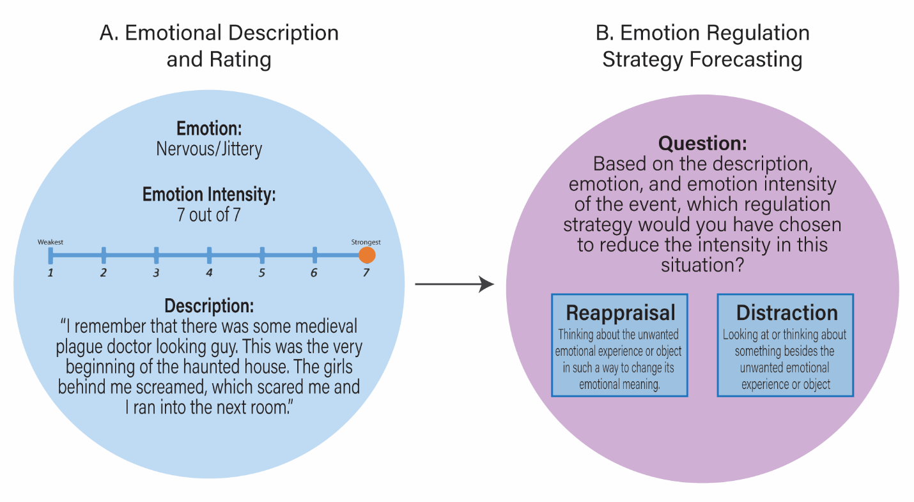

**Fig 5.** Study 2: Task Overview - One hundred and seventy (170) participants (strategy forecasters) read the descriptions that preliminary study participants (strategy users) wrote about their emotional experience in the haunted house. **(A)** Strategy forecasters read the strategy users’ emotional descriptions and intensity rating. (**B**) Strategy forecasters indicated what regulation strategy (distraction or reappraisal) they predict they would use to regulate their emotions in the described event.

**Analysis.** To explore whether the affective intensity that strategy users reported influenced the strategies that strategy forecasters predicted, we again specified mixed effect binary logistic regressions accounting for the random effect of participant (both the strategy forecaster and strategy user of each observation) using the “lme4” package (Bates et al., 2015) in R (R Core Team, 2022) and followed an information theoretic approach via AIC comparison. Fixed effects models were built iteratively from and compared to our null model (*ICC* = 0.14). All data and scripts used to produce this analysis are publicly available at OSF (*See* **Open Practices**). The design and hypotheses of Study 2 were preregistered with AsPredicted (<https://aspredicted.org/XXH_W1V>), though please note a discrepancy exists in the number of events used, as fewer events met our outlined criteria than initially determined.

**STUDY 2 RESULTS**

**Study samples were similar across individual difference measures.** Our first analyses aimed to determine whether relevant trait differences existed between the sample of strategy forecasters and the sample of strategy users. If such differences exist, they would limit our ability to associate differences in regulatory forecasting or usage to differences in presentation and context. Both preliminary and Study 2 participants completed the ERQ and IUS. If differences exist in ERQ scores, the groups may differ in their underlying propensity to choose specific strategies. Using a Welch’s Two Sample T-Test, we did not find significant differences between the groups in their likelihood of using reappraisal (*x users* = 29.9, *x forecasters*= 31.0, *95% CI* = [-3.22, 1.03], *t*(44.6) = -1.04, *p* = 0.305) according to the ERQ reappraisal subscale. However, significant differences were observed between the two groups for the expressive suppression ERQ subscale (*x users* = 12.5, *x forecasters* = 15.7, *95% CI* = [-5.03, -1.32]. *t*(48.1) = -3.44, *p* = 0.001). The relevancy of the suppression subscale is unclear in this context, as suppression is not directly tested and neither subscale proved to be predictive of strategy usage during our preliminary study. Furthermore, a bivariate linear model found that neither the ERQ reappraisal subscale (*b* = -0.001, *se* = 0.002, *p* = 0.58) nor the suppression subscale (*b* = 0.002, *se* = 0.002, *p* = 0.35) predicted the proportion of trials in which participants selected reappraisal rather than distraction in this study as well. Additionally, if differences exist in IUS scores, the groups may differ in how they respond to ambiguity or uncertain situations; perhaps especially relevant given that “confused” was the most cited negative emotion in Study 1. However, no differences were observed in IUS scores across groups (*x users* = 33.6, *x forecasters* = 34.3, *95% CI*= [-7.07, 5.59], *t*(34.9) = -0.238, *p* = 0.813). Assessing differences in difficulties in applying emotion regulation strategies via DERS subscales was not possible because it was not administered to preliminary study participants.

**Intensity predicts regulatory strategy forecasts.** Our first model -- containing only the affective intensity of strategy users as a predictor to predict strategy forecasters’ predictions - performed better than our null model (*χ2*(1, *N* = 25232) = 8.39), demonstrating a small positive effect (*OR* = 1.06, *95% CI* = [1.02, 1.10], *p* = 0.004) such that more intense events were associated with an increased probability that participants predicted choosing distraction to regulate them. Additional models included age, gender, IUS score, the DERS limited access to strategies subscale, and a combination of all four as covariates. However, each model failed to outperform our initial model in chi square tests of the models (age: *χ2*(1, *N* = 25232)= 0.84*, p* = 0.36; gender: *χ2*(2, *N* = 25232)= 2.81, p = 0.25; IUS: *χ2*(1, *N* = 25232)= 1.25, p = 0.26; DERS: *χ2*(1, *N* = 25232)= 0.54, p = 0.46; combo: *χ2*(5, *N* = 25232)= 4.52, p = 0.48; respectively).

**Strategy forecasters matched strategy users less than chance when selecting distraction.** In signal detection theory, d prime (*d’*) is a measure of sensitivity that quantifies the ability to distinguish between signal and noise in a binary decision task, and thus, can be used to determine whether congruency in strategy between strategy forecasters and strategy users is greater than chance. D prime is calculated as the normalized value of the proportion of hits (i.e., when a strategy was used by a strategy use participant and predicted by a strategy forecasting participant) minus the proportion of false alarms (i.e., when a strategy was not used by a strategy use participant but was predicted by strategy forecasting participant). Importantly, d’ is robust to unequal prior probabilities in binary outcomes, as occurs in our strategy selection (73.1% of preliminary study observations used distraction) through the incorporation of a bias parameter. Using this approach, we found that strategy forecasting participants matched the experiences of strategy using participants in their selection of reappraisal nearly at chance (*d’* = -0.08) but were below chance in matching distraction (d’ = -0.41) (**Fig. 6**). The difference in selection congruency between these strategies was significant as determined by a paired samples t-test (*x diff* = 0.328, *95% CI* = [0.313, 0.342], *t*(149) = 43, *p* < 0.001), suggesting that differences in the deployment of distraction between the two groups may be driving differences in how predictive affective intensity was towards strategy forecast or usage across these two contexts. The distribution of strategy selection differed between our strategy forecasting sample and strategy use sample, as distraction was only selected in 48.8% of observations for Study 2. Taken together, we found that participants used emotional intensity to inform their ER strategy predictions but not strategy usage and that the predicted utility, and thus frequency, of using distraction in such a context might not reflect what is experienced in practice.



***

**Fig 6.** The strategies participants predicted they would use were assessed against the strategies that were reported as used in each situation. While neither strategy was reported greater than chance, participants were significantly more likely to predict using reappraisal on trials when distraction was actually used when compared to predicting distraction when reappraisal was actually used.

**STUDY 3 METHODS**

Though affective intensity failed to predict ER usage in a high-intensity, quasi-naturalistic setting, participants presented with descriptions of events that were regulated by ‘strategy users’ were more likely to forecast using distraction to regulate events described as high intensity and reappraisal for events described as being of a lower intensity. The different results observed in these studies are difficult to compare, though, as many features differ between the approaches. Participants in Study 1 experienced the haunted house, were not trained or prompted to self-regulate, experienced the emotions that they reported, and reported the regulatory strategies that they used. Participants in Study 2 simulated the experiences of the haunted house, were instructed in ER strategies and prompted to make a forecast, did not experience the emotions associated with the event, and reported what strategy that they forecasted they might use in the given situation. Furthermore, Study 1 did not attempt to manipulate the emotions of participants, instead prioritizing ecological validity. A study which keeps instruction and stimulus exposure constant while differing the type of regulation (i.e., strategy forecasting v. usage) measured would be more conducive for direct comparisons of these two regulation processes. Study 3 attempted to rectify these discrepancies using a 2 between (condition: forecast v. experience) x 2 within (intensity: low v. high) mixed study design. Because we could not incorporate an immersive experiential component such as in Study 1 in this experimental design[1], we instead used clips from lesser-known horror films to elicit regulatory response to feature-rich, dynamic representations of negative emotion. This design allows us to directly compare the differences in regulatory behavior among untrained and unprompted participants when either reporting actual usage or forecasted selection in response to high and low intensity stimuli.

We originally hypothesized that we would replicate the results of Study 1 and Study 2: that participants placed within the “strategy user” condition would not demonstrate a relationship between stimulus intensity and regulation strategy usage, while participants in the “strategy forecaster” condition would demonstrate the canonical relationship between stimulus intensity and regulation strategy usage (i.e., as affective intensity increases the likelihood of relying upon distraction also increases). Counter to our predictions, we found that both conditions demonstrated characteristics of this canonical relationship; however, important differences in ER strategy and effectiveness were also observed across the two conditions. We report how we determined our sample size, all data exclusions, all manipulations, and all measures in the study.

**PARTICIPANTS:** In October 2023, 247 participants (age: *x̄ age* = 38.57 yrs, *range* = 20 -76 yrs, *sd age* = 12.24 yrs; gender: 94 female, 152 male, 1 non-binary) consented to an IRB-approved online study described as using clips from horror films to explore emotions and behavior. Participants completed the study on Pavlovia and were recruited/filtered via Prolific. Eligible participants were native English speakers residing in the US between the ages of 18 and 85, had normal or corrected-to-normal vision, had no history of reading-related disorders or literacy difficulties, as well as no history of mild cognitive impairment, head injury leading to unconsciousness, or unregulated mental health diagnosis. The racial identity of participants was as follows: 08.9% Asian, 06.9% Black, 05.7% Hispanic, 09.3% Mixed, 04.6% Other, and 64.6% White. Socioeconomic status was well distributed with 09.3% reporting a household income of under $15,000 per year, 09.3% between $15,001 and $25,000, 10.5% between $25,001 and $35,000, 13.4% between $35,001 and $50,000, 19.0% between $50,001 and $75,000, 13.8% between $75,001 and $100,00, 08.1% between $100,001 and $150,000, 06.9% above $150,000 and an additional 04.9% who did prefer not to say. In response to the question, “How much do you enjoy watching horror movies”, the average participant response was a 2.95 on a scale from 0 to 6, with 0 corresponding to “Not at all” and 6 corresponding to “Extremely” (*median*  = 3, *sd*  = 2.16).

Sample size was determined via *a priori* power analyses assuming an attrition rate of 10%, *r2* ≤ 0.10 for covariates, and the most conservative effect size observed in our previous studies (*OR* = 1.30). To achieve 1-β = 0.80 (*α* = 0.05, two-tailed), at least 240 participants were required, or 264 when accounting for attrition. Up to 300 slots were made available on Prolific to account for returned or incomplete research participation. Five participants were excluded for failing attention checks (*n* = 1) and familiarity with the stimuli (*n* = 4). Though we did not meet our recruitment goal of *n* = 264, our sample (*n* = 242) still surpassed the threshold calculated to achieve sufficient power. Participants were paid at a rate of $12.00/hr.

**MATERIALS AND PROCEDURE:** Participants completed a web browser-based task built primarily with jsPsych v7.0 (De Leeuw et al., 2023). Following consent and a disclaimer regarding the content of the stimuli (i.e., gore, violence, mature language, harm to self or others), participants were instructed to complete the study in an isolated, distraction free space without others present to improve immersion. Participants were also instructed to set audio to a comfortable but audible level, to silence their phones, and to minimize or close other programs. To further standardize the experience and minimize distractions, the task was programmed to automatically run the browser in full screen mode and the task was programmed to stop if full screen mode was exited. Mobile devices, tablets, and screens with a resolution of less than 700 x 1250 pixels were eligible to participate.

Participants were instructed to watch and react to each of the four video clips as they naturally would. These instructions appeared as a reminder before each video played. Before each stimulus, participants were asked, “How intense are the negative emotions that you feel before starting this clip?” with responses captured on a linear sliding scale ranging in values from 0 (labelled “Not at all Intense”) to 100 (labelled “Extremely Intense”). Which side of the scale corresponded to which label was counter-balanced across participants. The default value of the slider thumb was set to 50 and participants were required to interact with the slider thumb before progressing. As participants moved the slider thumb, the value corresponding to its position was visualized and updated accordingly. Video order was randomized. After each video, participants were asked, “How intense were the negative emotions that you felt while watching this clip?”. Responses were captured using the same scale as previously described. However, participants were also reminded of the value that they had selected prior to starting the video (e.g., a participant who indicated a 77 on the scale before watching the video saw the message: “Before this video, you reported your negative emotions were a: **77**”).

All video clips were 120 seconds in length and pulled from relatively lesser-known independent horror films, including *Vicious Fun* (Particular Crowd, Black Fawn Films), *The Marshes* (28 Productions), *Head Count* (Godmother Industries), and *Superhost* (Superchill). Forty hypothesis-blind independent raters watched and rated these clips, as well as six other films on a scale from 0 to 100 across metrics including arousal, valence, narrative coherence, and familiarity. These four clips were chosen due to their low average familiarity values (*range x̄ = 0.25 – 6.05) --* indicating that few participants would have likely seen them before -- and negative median valence scores (i.e., values below 50; *x̄ Vicious Fun* = 15, *x̄ The Marshes*  = 01.5, *x̄ Head Count*  = 33.5, *x̄ Superhost*  = 25.5). They were also chosen for having either relatively high or relatively low median arousal scores (*x̄ Vicious Fun* = 77.5, *x̄ The Marshes*  = 70, *x̄ Head Count*  = 50.7, *x̄ Superhost*  = 58.5) and minimal variance around those values. This allowed us to attempt to manipulate the affective experiences of participants to influence self-regulation behaviors.

After viewing and rating all videos, Study 3 participants were assigned to either a “strategy use” (*n* = 130) or “strategy forecast” (*n* = 112) condition. Both conditions were given descriptions and examples of distraction and reappraisal that mirrored those used in Study 2 (though, ‘haunted house’ was replaced with ‘horror movie’). Whether participants received the description and examples of distraction or reappraisal first was counterbalanced across participants. However, following these descriptions participants were asked either, “Which strategy, if any, did you use to regulate your negative emotions while watching this clip?” (strategy use condition) or “Which strategy, if any, would you predict the average person would use to regulate their negative emotions while watching this clip?” (strategy forecast condition). Participants responded to this question by selecting either “Reappraisal”, “Distraction”, or “Neither”. The order in which these options appeared were randomized for each participant. Reminders of what the three options referred to appeared below these options. Reminders for participants in the strategy use condition read, “CHOOSE REAPPRAISAL if you changed how you thought about the video; CHOOSE DISTRACTION if you diverted your attention from the video; CHOOSE NEITHER if you did not implement either of the other two strategies”. Reminders for participants in the strategy forecast condition read, “CHOOSE REAPPRAISAL if they should change how they thought about the video; CHOOSE DISTRACTION if they should divert their attention from the video; CHOOSE NEITHER if they should not implement either of the other two strategies”. Note that a potential discrepancy exists between the phrasing of our strategy forecast instructions (“Which strategy … *would* you predict…) and reminders (“…if they *should* …”) which we discuss further in the limitations. If participants selected neither, they were not asked any further questions for that stimulus. If participants selected a non-neither option, they were asked how much the strategy they used reduced or the strategy they forecasted would reduce negative emotions while watching the stimulus on a 0 to 100 scale as previously described. Participants also either answered how effortful it was to use a strategy and how successfully they could use it, or how effortful that they predict it might be and how successfully they predict it could be used. These were each captured on 7-point Likert scales. Labels included “Not at all”, “Slightly”, “Somewhat”, “Moderately”, “Considerably”, “Very Much”, and “Extremely”. Participants responded to questions for each clip in the order that they clips were watched and a still from each clip was centrally-placed on the screen for each question to ensure participants understood which stimulus that they question was referring to. Following all questions, participants were asked to provide a brief example of both reappraisal and distraction in a free-response textbox to further assess task comprehension. Following the primary task, participants completed individual difference measures, including the Emotion Regulation Questionnaire, the Difficulties with Emotion Regulation Survey, and the Intolerance of Uncertainty Scale. Participants completed the study in 21.9 minutes on average (*median* = 20.5 minutes, *sd* = 56.0 minutes, *range* = 13.6 – 50.7 minutes). For additional information, see our OSF repository containing all task materials, including instructions and texts (*See* **Open Practices**).

**Analysis.** To explore whether affective intensity and condition influenced the strategies participants used or predicted, we again specified mixed effect binary logistic regressions accounting for the random effect of participant and stimulus using the “lme4” package (Bates et al., 2015) in R (R Core Team, 2022) and followed an information theoretic approach via AIC comparison. Fixed effects models were iteratively built from and compared to our null model (*ICC* = 0.162), which did not contain any fixed effects. All data and scripts used to produce this analysis are publicly available at OSF (*See* **Open Practices**). The design and hypotheses of Study 3 were preregistered with AsPredicted (<https://aspredicted.org/n3ne3.pdf>).

**STUDY 3 RESULTS**

**Video stimuli elicited predictable emotional responses.** To ensure that our emotion manipulation was successful, negative affective intensity ratings following each low- and high-intensity stimuli were compared using Welch’s Two Sample t-test, which found that our manipulation was successful (*x̄ high* = 53.5*, x̄ low*= 40.6, *95% CI* = [9.1, 16.8], *t*(948.1) = 6.61, *p* < 0.001). The average baseline intensity (i.e., intensity assessed prior to each video) was 27.4 pts (*median* = 19, *sd*  = 27.0) while the average post-exposure intensity was 47.1 pts (*median* = 50, *sd* = 30.9).

**Strategy forecasters and users reported no differences in emotional intensity.** Though participants were randomly assigned to conditions after having provided affective ratings, we wanted to ensure that any effects discovered between conditions could not be attributable to differences in experienced affective intensity. A Welch’s Two Sample t-test comparing affective intensity ratings between strategy users and forecasters both before (*x̄ user* = 26.2*, x̄ forecaster*= 28.8, *95% CI* = [-6.1, 0.8], *t*(908.3) = -1.50, *p* = 0.134) and after (*x̄ user* = 46.5*, x̄ forecaster*= 48.0, *95% CI* = [-5.4, 2.4], *t*(917.9) = -0.73, *p* = 0.460) stimulus exposure found no statistically significant differences in affective ratings. Strategy forecasters and users also did not differ across any relevant individual difference measures or demographics, including the reappraisal (*t*(198.6) = 0.14, *p* = 0.890) and suppression (*t*(222.57) = -1.94, *p* = 0.054) ERQ subscales, both Factor 1(*t*(235.0) = -0.94, *p* = 0.349) and Factor 2 (*t*(220.4) = -0.96, *p* = 0.336) of the IUS scale, the limited access to strategies subscale of the DERS (*t*(221.4) = 0.08, *p* = 0.938), age (*t*(220.0) = -0.14, *p* = 0.888), or horror enjoyment (*t*(225.9) = 0.12, *p* = 0.908).

**Intense emotional responses were more likely to be regulated.** To add greater ecological validity to a forced choice paradigm, we provided participants the option to indicate whether a stimulus should be regulated (i.e., reappraisal or distraction) or not regulated (i.e., neither). In line with hedonic motivations to self-regulate, we expect that videos of greater self-reported negative affective intensity should be more likely to be regulated; if that is not the case, then our design may generate noisy or counterintuitive results. To that end, we did find that videos in which participants selected neither distraction nor reappraisal were of a lower intensity (*x̄ regulated* = 53.3*, x̄ unregulated*= 36.7, *95% CI* = [12.7, 20.], *t*(735.6) = 8.30, *p* < 0.001) and a mixed effect binary logistic regression found that each standard deviation unit increase in affective intensity results in a 2.86 fold increase in the odds of self-regulation occurring (*95% CI* = [2.16, 3.78], *p* < 0.001).

**Strategy forecasters anticipated regulating more often than strategy users; Strategy users reappraised more often than strategy forecasters.** Overall, reappraisal was used or forecasted in 33.1% of trials, distraction was used or forecasted in 28.5% of trials, and 36.7% of trials were left unregulated or without either option being forecasted. To assess whether there were differences in the distribution of strategy usage or forecast by condition, which could have implications for our primary analysis, we conducted chi-square test on strategy use/forecast and condition, which found differences in the frequencies with which strategy forecasters and users left trials unregulated (*χ2*(1, *N* = 953) = 120.35, *p* < 0.001) and used or forecasted a regulation strategy (*χ2*(1, *N* = 613)= 6.14, *p* = 0.013). More precisely, strategy users reported regulating (52.6%) and not regulating (47.4%) about equally while forecasters heavily favored regulating (82.2%) over not regulating (17.7%) across trials (**Fig. 7a**). Additionally, strategy users reported using reappraisal (59.8%) slightly more often than distraction (40.2%) while strategy forecasters predicted choosing both distraction (49.2%) and reappraisal (50.7%) about evenly (**Fig. 7b**).

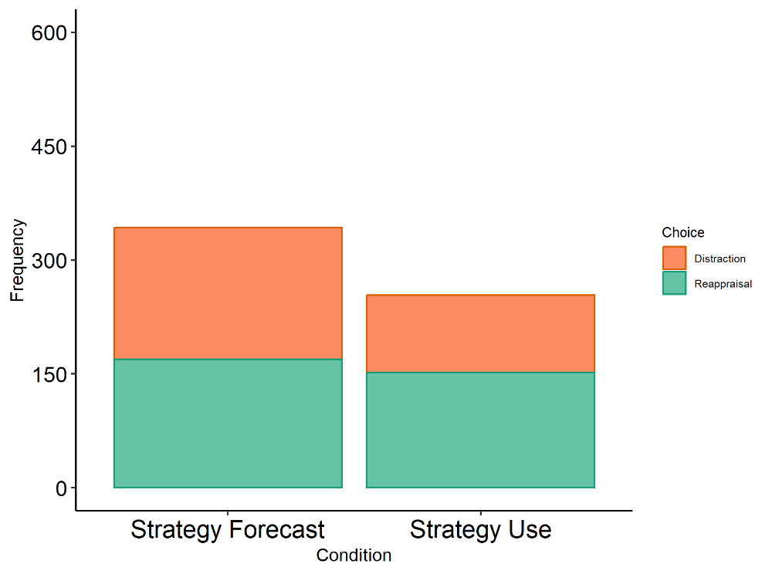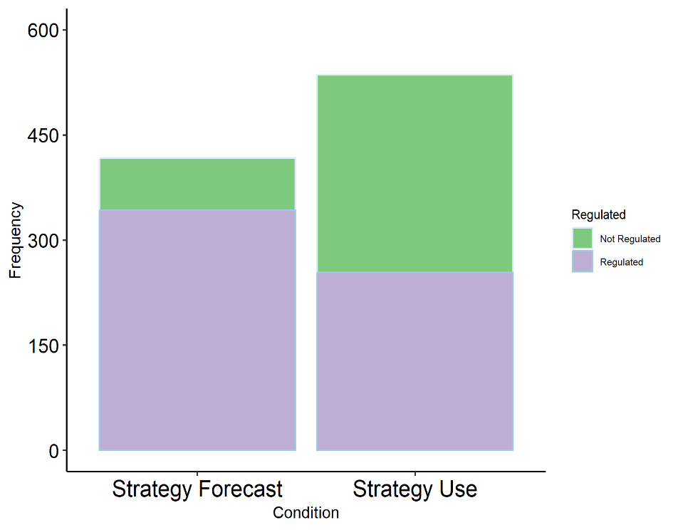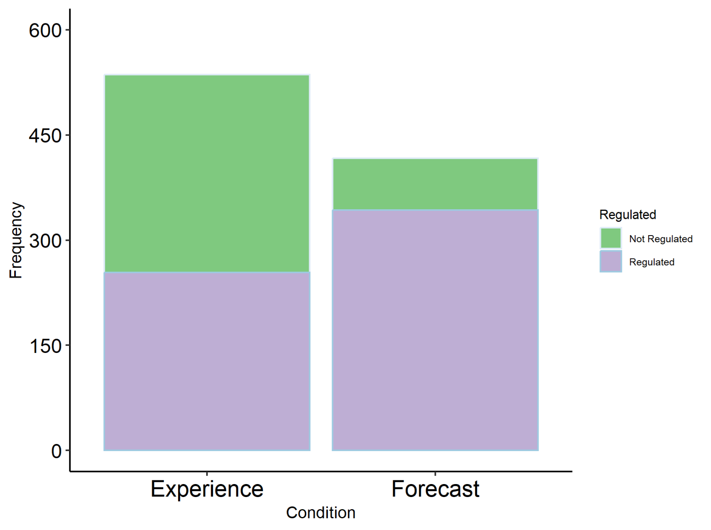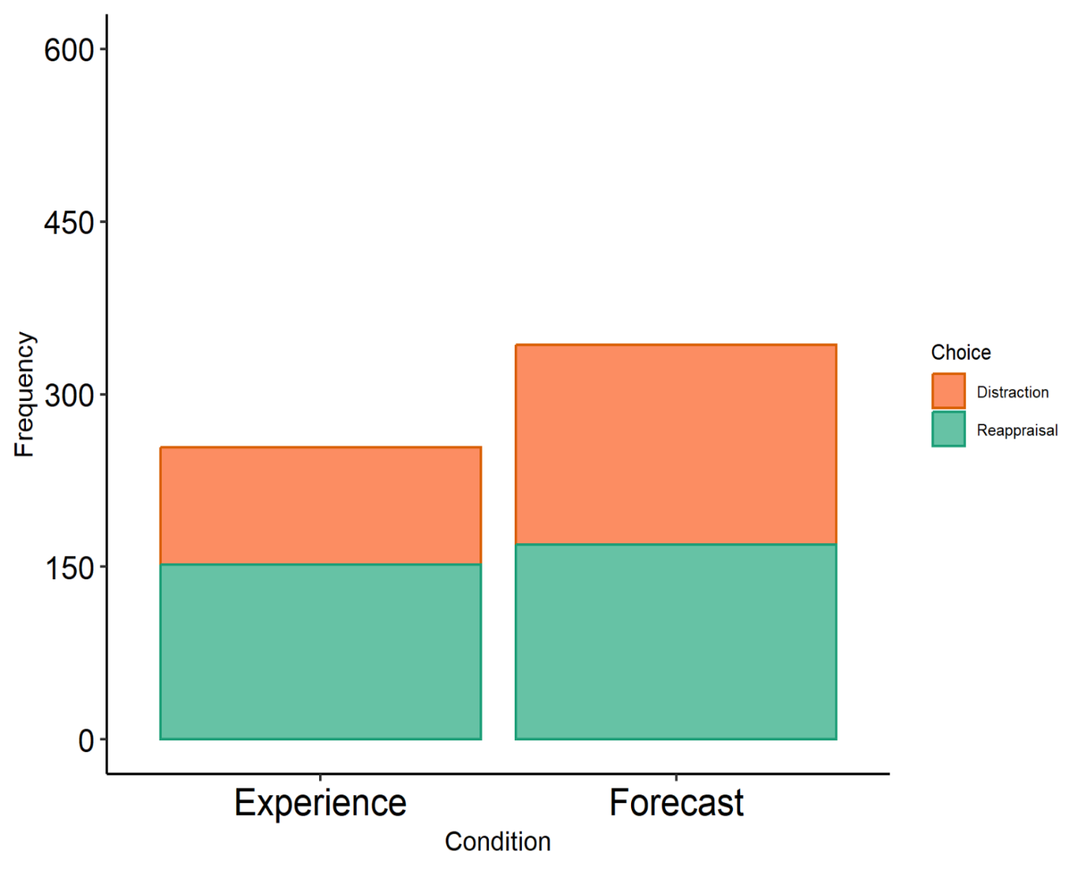

**Fig 7.** Chi-square tests highlighted that: **(A)** strategy users were more likely to not regulate a stimulus than strategy forecasters, but that (**B)** strategy forecasters more evenly used both strategies when predicting strategy selection.

A.B.

**Strategy forecasters and users differ in strategy selection probability at low, not high, intensities.** Following the analysis plan outlined within the Study 3 methods sections, we compared models via chi-square tests that included fixed effects for post-exposure affective intensity, baseline affective intensity, condition, and an interaction between post-exposure affective intensity and condition. These models were built iteratively, adding one effect at a time. Our best fitting model included all four terms (*χ2*(1, *N* = 597) = 4.205, *p* = 0.040) and found the interaction was predictive of strategy usage/forecasting (*OR* = 0.56, *95% CI* = [0.36, 0.87], p = 0.010). Having tested the model that we hypothesized, we identified a selection of possible covariates (age, horror, enjoyment, ERQ subscales, IUS subscales, and the DERS limited access to strategies subscale) and iteratively added them to the model in order of most correlated with the outcome variable to pursue the model of best fit. Only the addition of the reappraisal ERQ subscale improved model fit above that of our hypothesized model (*χ2*(1, *N* = 597)= 9.3587, *p* = 0.002). This model yielded a significant interaction term (*OR* = 0.61, *95% CI* = [0.39, 0.95], *p* = 0.029) and suggests that condition is moderating the relationship between affective intensity and strategy usage/forecasting. More specifically, at high intensities both strategy forecasters and users are similar in their likelihood of predicting or using distraction, respectively. However, in congruence with forecasters predicting to choose reappraisal less than strategy users used it in practice, strategy forecasters are less likely to predict choosing reappraisal than strategy users were to use reappraisal at lower intensities (**Fig. 8**).

**Strategy forecasters and users differ in regulation effort.** Participants in both conditions failed to generate significant differences in how much effort they exerted or predicted that they would exert to use reappraisal and distraction (*F*(1, 215) = 0.392, p = 0.532). However, the participants in the use condition did differ from participants in the forecasting condition in how effortful regulation was across strategies, even when adjusting for strategy usage/forecast (*F*(1,215) = *3.820*, *p* = 0.045). Bonferroni-adjusted post-hoc contrasts determined that this difference is primarily driven by reappraisal; experiencers reported that reappraisal was more effortful than forecasted predicted it would be (*x̄ user* = 3.11*, x̄ forecaster*= 2.60, *95% CI* = [0.13, 0.88], *t*(296.5) = .66, *p* = 0.016).

**Fig 8.** Mixed effects binary logistic regression found that intensity predicts strategy usage and prediction for both strategy users and forecasters, respectively. However, at lower intensities, strategy forecasters are less likely to predict selecting reappraisal than strategy users were to use reappraisal.

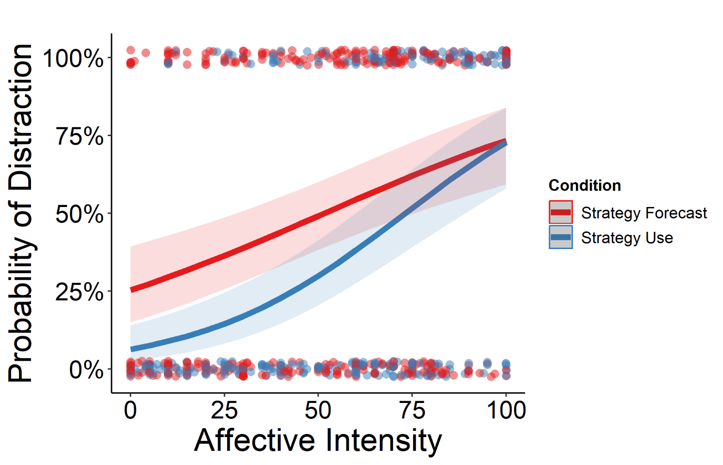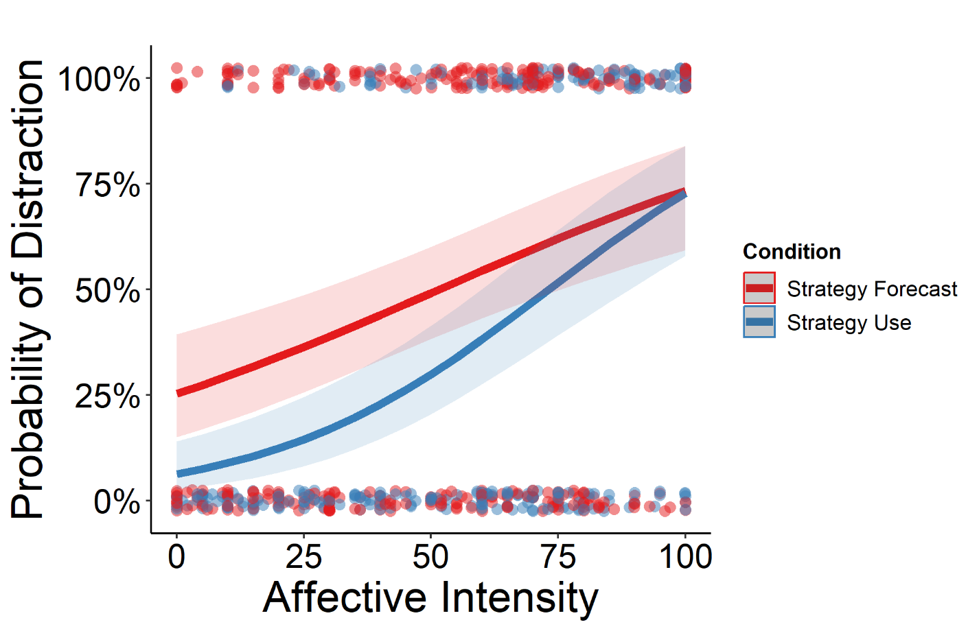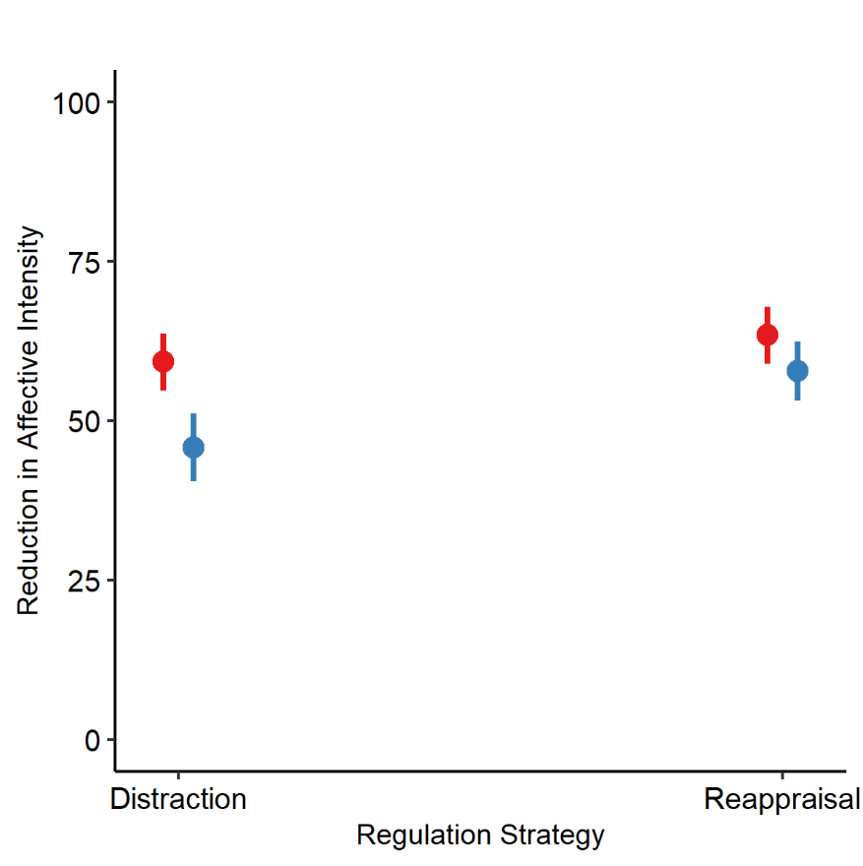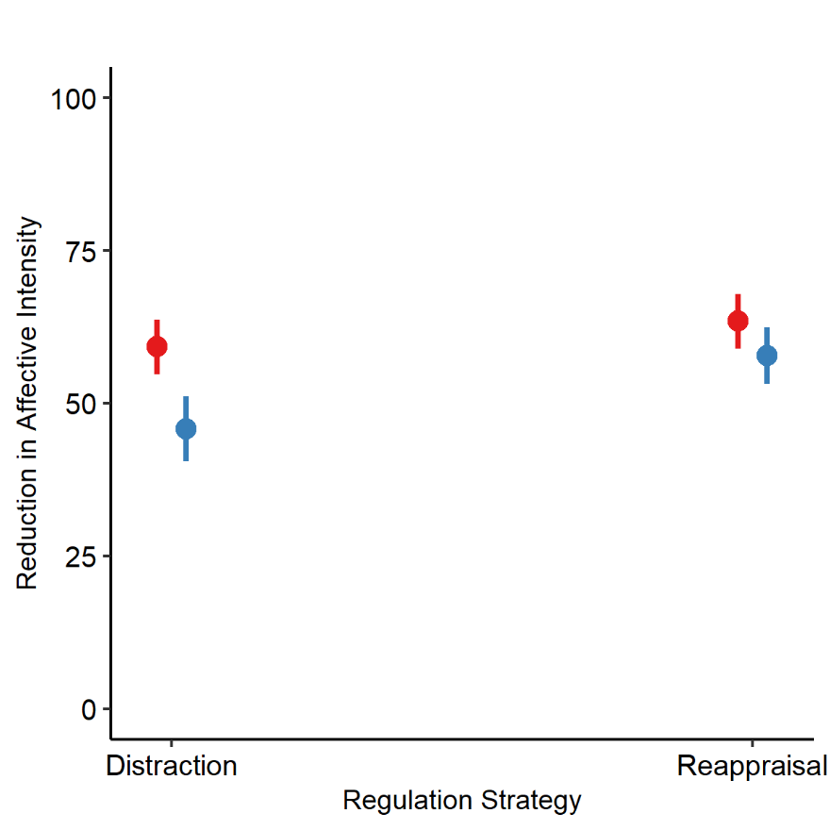

**

**Fig 9.** Strategy forecasters predicted that distraction would reduce negative affective intensity by a greater magnitude than strategy users reported that it actually had.

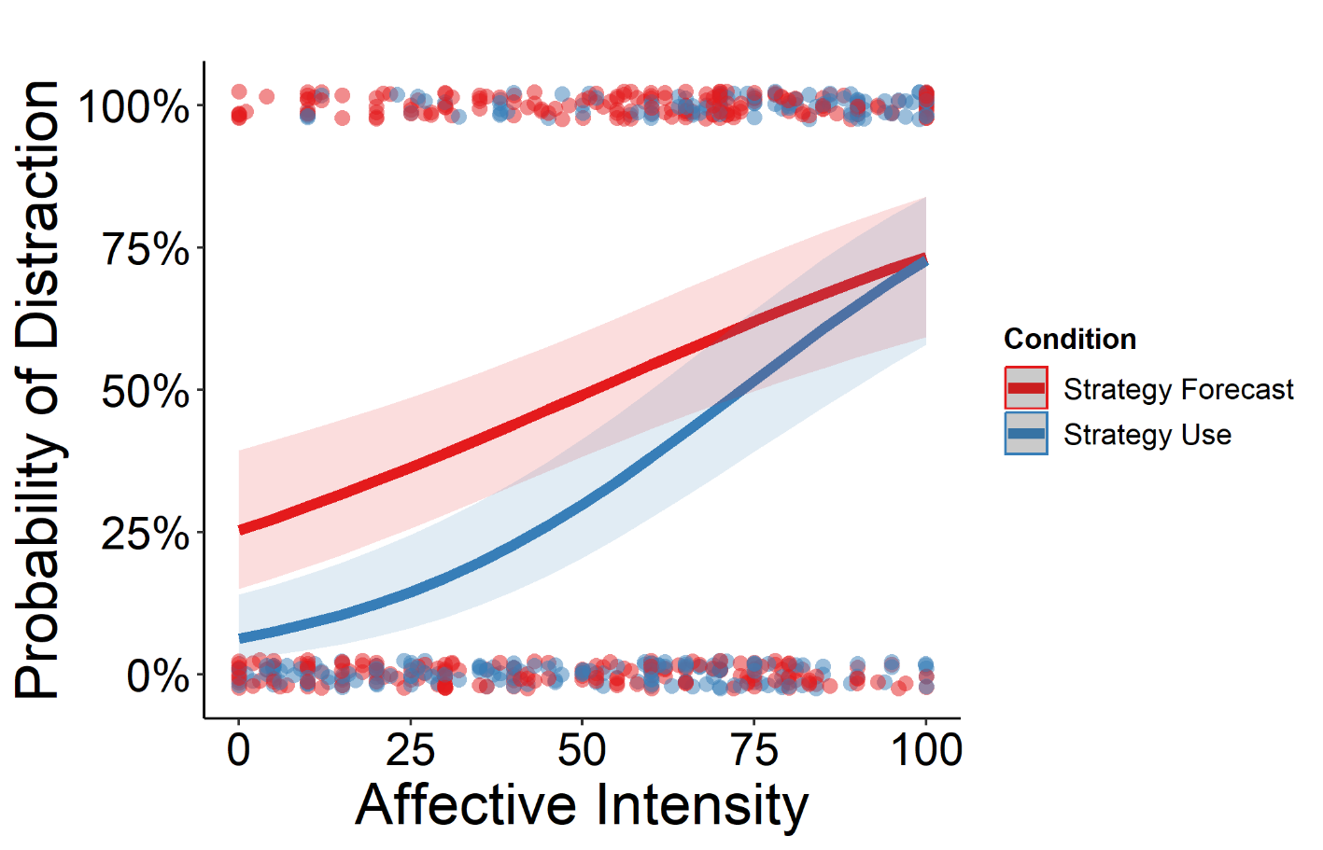

**Strategy forecasters and users differ in regulation intensity reduction.** When examining how effective participants thought the strategies would be at reducing affective intensity, adjusting for the random effect of participant, we found a significant main effect of strategy (*x̄ reappraisal* = 61.9*, x̄ distraction*= 54.5, *95% CI* = [3.31, 11.48], *t*(582.12) = 3.55, *p* < 0.001) and condition (*x̄ users* = 55.0*, x̄ forecasters*= 61.1, *95% CI* = [-10.32, -1.85], *t*(494.6) = -2.83, *p* = 0.004), but more intriguingly, in an interaction model we found a significant interaction between the two variables (*F*(1,377) = 4.31, *p* = 0.038). A subsequent Bonferroni-adjusted contrast revealed a significant difference between strategy users and forecasters in how effectively distraction reduces affective intensity (*x̄ users* = 48.0*, x̄ forecasters*= 58.3, *95% CI* = [-16.62, -4.13], *t*(198.2) = -3.28, *p* = 0.001) **(Fig 9)**. This finding is congruent with findings from both Study 1 and Study 2 in which individuals seem to overestimate or mispredict the effectiveness of distraction, but not reappraisal, within these settings.

**GENERAL DISCUSSION**

Three studies examined the association between emotional intensity and regulation strategy usage in response to dynamic, multimodal stimuli of varying intensity. Study 1 tasked untrained participants with recalling emotional and spontaneous regulatory behaviors in a surprise recall task after exposure to a high-intensity multi-modal context (a haunted house). Affective intensity did not predict strategy usage. Though distraction was used more often than reappraisal, distraction was less successful at regulating in response to high affective intensities in this context. Study 2 found an association between affective intensity and strategy usage among participants forecasting regulatory behavior in response to descriptions of regulated events that haunted house participants actually experienced. However, strategy forecasters overpredicted how often distraction was used by participants who regulated within the haunted house (i.e., strategy users). Study 3 measured differences between strategy users and forecasters regarding ER within the same study and found significant differences between strategy forecasters and users in how often distraction was forecasted or used and how effective the groups predicted or reported distraction to be, respectively. The present findings highlight challenges in translating ER theory to real-world application, as complex, dynamic situations in everyday life may strongly influence the efficacy and frequency with which regulatory strategies are used.

These results add nuance to our understanding of affective intensity’s influence upon regulation strategy application and complements research on environmental affordances, or the extent to which features of a situation lend themselves to either distraction or reappraisal (Suri et al., 2018; Young & Suri, 2020). It is possible that individuals initially regulated their emotions with the strategy they believed had the greatest value (i.e., the most effective strategy with the lowest effort investment; typically distraction) based upon models of regulation they had previously generated from experiences with similar media, as outlined by computational decision-making frameworks of ER (Etkin et al., 2015). However, the unrelenting, attention-grabbing nature of challenging high-intensity situations may grant few affordances by which to distract oneself. On the other hand, reappraisals may appear to be less valuable initially, resulting in lower usage, but could be more effective when used due to a relatively greater volume of environmental affordances (i.e., things to repurpose or reconstrue (Uusberg et al., 2019); e.g., actors, props, goals, etc.). This explanation mirrors the strategy-selection relationship hypothesized by Etkin and colleagues (2015) who posited that a more explicit, higher-cost, model-based approach to ER may be applied more effectively when implicit, or model-free, ER tendencies were not arriving at their desired goal via prediction error adjustment alone. Distilling events down to a text-based representation or video, as had been done in Studies 2 and 3, may provide greater distraction affordances and rebalance the likelihood of individuals choosing or predicting reappraisal or distraction in situations when it would canonically make sense to do so.

How a person passively assesses the emotionally-relevant features of an environment may guide regulatory behaviors, but so too might the action affordances – opportunities to move, modify, or engage with the environment – that a situation presents. Action-oriented perspectives on ER emphasize that emotion regulation behaviors are a product of active processes, such as forward modelling (Bramson et al., 2023). Common associations between self-regulation, emotion, and activity in the sensorimotor and pre-motor systems illustrate how entangled action is with regulation (Bramson et al., 2018; Mobbs et al., 2007; Saarimäki et al., 2016). The degree to which one is free to physically navigate their space or interact with evocative stimuli may have important implications on situational appraisals, thus informing which strategies participants predict may or may not work (Ridderinkhof, 2017). **Figure 5** highlights one example of this within the haunted house, as a participant was able to mitigate a negative emotional reaction by physically circumventing the stimulus. Stimulus-response paradigms which situate participants in stationary positions or lack contexts enveloping the emotionally-evocative stimulus may not be well suited for modeling the effect that these factors have upon typical or daily ER strategy usage.

Hot-cold empathy gap research, which measures forecasting differences between how people think they will feel hypothetically and how they feel in practice (Loewenstein, 1996), are relevant as well. Individuals in “cold states” consistently underpredict the challenges associated with meeting affectively-relevant goals during “hot states” (Sayette et al., 2008; Van Boven & Loewenstein, 2003). Such a pattern mirrors the differences observed between Studies 1 and 2, wherein decontextualizing events (i.e., shifting from a hot state to a cold state) yielded a predictable pattern in strategy choice not observed during hot state ER usage. They also mirror differences in strategy usage and success. Such patterns highlight that emotion self-regulation is a complex, multi-faceted construct and different proportions of its variability may be better captured by different approaches (Friedman & Gustavson, 2022). Though this study is the first to our knowledge that has utilized a high-intensity, dynamic, feature-rich paradigm to demonstrate this in the domain of ER, similar approaches have demonstrated similar discrepancies in the moral domain (FeldmanHall et al., 2012). Computerized lab tasks have been theorized to assess regulatory performance in optimal conditions (Wennerhold & Friese, 2020) and this may contrast study designs such as Study 1, which may be closer to performance in typical conditions, and Studies 2 and 3, which may be somewhere in-between (Friedman & Gustavson, 2022). Though participants may be capable of performing self-regulation at high levels in optimal conditions, they may not feel motivated to do so in typical conditions (Grund & Carstens, 2019).

**Limitations & Future Directions.** There are several limitations in our experimental approach that demand attention. First, our Study 1 aims were relatively narrow in comparison to the vast ER behavior variability captured by this dataset and resulted in excluding many observations that did not meet our inclusion criteria (*See* **Fig. 2**). More analyses would be required to fully explore this space. Additionally, though many features of our design mirror regulation of emotions in everyday life, haunted houses may have limited generalizability to other high-intensity settings that we commonly experience (Clasen et al., 2019; Tashjian et al., 2022) and the purpose haunted houses commonly serve (i.e., entertainment) could also circumscribe their generalizability to graver situations. The use of a haunted house as our setting also may have resulted in self-selection biases within our sample. It must be noted that we did not directly manipulate emotional intensity within this design and most of the self-report data that we did collect was captured post-exposure, not during exposure. Thus, without manipulation, it is unclear whether self-reported emotion intensity in Study 1 represents a precursor to regulation, a product of regulation, or some combination of the two. Although computing standardized emotion scores of each event within the haunted house would be ideal and theoretically possible, the limited window in which we had to collect our experimental data made it difficult to assemble an additional independent sample for this purpose. While we chose language which aimed to target emotion as a precursor, it is entirely possible that subjects may have misremembered or misinterpreted this intent. While some of our exploratory analyses suggest that the relationship between intensity and self-regulation failed to materialize even with stimulus manipulation (i.e., using section as a predictor of regulation), because of this design, the results of Study 1 analyses may not be conclusive. Additionally, we unfortunately did not have measures of startle sensitivity or fear-enjoyment from Study 2 participants. Thus, we cannot compare our Study 1 and Study 2 samples along these metrics, which explain some of the differences in regulatory behaviors between samples. Studies 2 and 3 were also conducted entirely online. Though means of standardizing the experience were attempted, we have less control than possible in an in-person context and cannot guarantee that participants were fully focused on study tasks. Additionally, the choice to homogenize stimuli for strategy forecasters and users in Study 3 may have also unintentionally homogenized the regulation processes that we intended to target. In other words, forecasters may have just been tempted to report the strategies that they used and users may have been tempted to report what they *would* have used had they regulated. However, the inclusion of a “no regulation” option was intended to reduce the latter possibility.

Participants in Study 3 were initially instructed to predict what strategy they believed the average person *would* choose while the strategy reminders phrased strategy selection as what average persons *should* choose. Both phrasings do imply some form of forecasting, but the former may be more likely to elicit *descriptive* forecasts and the latter more likely to elicit *prescriptive* forecasts, and these may lead to different regulatory conclusions. For example, a person might know that they *should* reduce stress by seeking therapy but might instead engage in maladaptive methods of stress-reduction, such as substance abuse. Choice normativity (i.e., variance around which action one *should* take) is well-studied in health, moral, and social psychology but has been comparatively unexplored in emotion regulation. Extant ER literature highlights variance around how people regulate, but not necessarily around how they think they should regulate or how they think they would regulate. Regardless, this inconsistency may have introduced confusion into participant forecasting and the extent to which this may have had impacts upon the outcome of Study 3 is unknown.

A small but important contingent of the existing ER literature has highlighted intra-strategy heterogeneity in the regulation techniques that we had examined (Uusberg et al., 2019; Webb et al., 2012). For example, Webb and colleagues identified at least three distinct ER approaches that could be categorized as reappraisal (i.e., reappraising the stimulus, reappraising the emotional response, reappraisal via perspective-taking) and these reappraisal subtypes demonstrate varying effectiveness in modulating emotion depending upon situational and personal factors. It may be the case that specific types of reappraisal and distraction demonstrate an intensity-selection relationship that better mirrors the canonical association observed in lab studies, but testing such a question with sufficient power would necessitate far more observations than are available in this dataset.

Due to resource constraints, participants also necessarily experienced the haunted house in groups. Although participants were instructed to not discuss their experiences and post-hoc analyses failed to find any association between group membership and strategy usage, the group context in which the experience occurred could have influenced behavior and cognitive perceptions in unknown ways. The presence and strength of friendship among group members was also assessed and was not predictive of regulation. Lastly, some events, particularly in the preliminary study and multiverse analyses, had to be captured at a one-week delay due to collaboration with a memory study, which calls into question the reliability of some responses. Future research should limit the delay between experience and report as much as possible without interfering with emotional events. Future research might also take interest in the order of strategies reported in regulation-challenging situations; that is to say, does the likelihood of using a reappraisal strategy for a given person in this context increase with each failed attempt to engage distraction? Although we did not have sufficient observations to examine the data with such granularity, examining associations between the intensity of specific emotions and regulation usage might also be of particular interest to future researchers in this space (Young & Suri, 2020). Despite its limitations, this dataset and approach may be of interest to those exploring spontaneous regulation tendencies from untrained participants in response to both positive and negative events.

**Conclusion.** Taken together, the present studies represent what we believe to be the first attempt to extend the association observed between affective intensity and different ER behaviors to dynamic, multimodal and high-intensity settings using untrained participants. This approach offers an alternative means of exploring ER usage while pursuing greater ecologically-valid in study design. Our data and results may be of particular interest to other emotion, self-regulation, and cognitive control researchers interested in quasi-naturalistic design. In failing to replicate lab results with Study 1 but finding a modest association in Studies 2 and 3, we may offer greater support for the importance of context in determining the fit of ER strategies, though the limitations inherent to this study leave room for other possibilities. Ultimately, though, this study highlights the importance of extending what we know about regulation in relatively mundane, controlled situations to those crowded, loud, and perhaps uncontrollable contexts in which emotion regulation success could be of dire consequence.

**Acknowledgments:**

We sincerely thank Ian O’Shea, Isabel Leiva, Angelique Vittone, Lauren Iglio, Kathryn Lockwood, Devlin Eckardt, Adhya Gowda, Troy Houser, Marissa Ballew, Kaitlin Dow, and Mary Nolwenn Achy for collecting and/or coding data.

**Declaration Of Conflicting Interests:**

The authors declared that they had no conflicts of interest with respect to their authorship or the publication of this article.

**Funding:**

This work was funded in part by the Brain and Behavioral Research Foundation’s NARSAD Young Investigator Award received by Vishnu P. Murty and by the National Science Foundation (Grant No. 2123474).

**Author’s Note**:

Earlier versions of this manuscript have been available on PsyArxiv (<https://osf.io/preprints/psyarxiv/23wtz>) since November 28th, 2022. Posters containing some of this data and analyses have been presented at the 2021, 2022, and 2024 Society for Personality & Social Psychology Conference, as well as the 2022 Society for Affective Science Conference. A symposium containing these findings was presented during the 2024 annual conference of the Association of Psychological Science. Invited presentations using some of these data and analyses occurred in 2020 at the Temple University Motivational Behavior Seminar Series and in 2023 to the March Lab at Florida State University and Satpute Lab at Northeastern University. Stasiak et al., 2023 was published using physiological and emotion data from the preliminary study. Cliver et al., In Press was accepted for publication using memory data from the preliminary study and Study 1.

**Transparency and Openness Practices:**

The preregistration for Studies 1, 2, and 3 can be found at [https://aspredicted.org/DP1_453,](https://aspredicted.org/DP1_453) <https://aspredicted.org/XXH>[_W1V,](https://aspredicted.org/XXH_W1V) and <https://aspredicted>.org/n3ne3.pdf, respectively. Deidentified data, analysis and data cleaning scripts, questionnaires, and data collection files to replicate the findings have been made publicly available via OSF and can be accessed at <https://osf.io/j5sku/?view_only=89d87669e7674096819c439ca109c483>. All products generated from this data, including powerpoints and posters highlighted under the Author’s Note have been made available within this repository as well.

**CrediT:**

**William J. Mitchell:** Conceptualization, Methodology, Software, Validation, Formal analysis, Investigation, Data Curation, Writing – Original Draft, Writing – Review & Editing, Visualization, Project administration. **Joanne Stasiak:** Conceptualization, Methodology, Investigation, Resources, Data Curation, Writing – Review & Editing, Project administration. **Steven Martinez:** Conceptualization, Investigation, Data Curation, Project administration. **Katelyn Cliver:** Conceptualization, Investigation, Data Curation, Project administration. **David Gregory:** Conceptualization, Investigation, Data Curation, Project administration. **Samantha Reisman:** Conceptualization, Investigation, Data Curation, Project administration. **Helen Schmidt:** Software, Validation, Formal analysis, Writing – Review & Editing. **Vishnu P. Murty:** Conceptualization, Resources, Writing – Review & Editing, Supervision, Project administration, Funding acquisition. **Chelsea Helion:** Conceptualization, Methodology, Resources, Writing – Review & Editing, Visualization, Supervision, Project administration.

**References:**

Aldao, A. (2013). The Future of Emotion Regulation Research: Capturing Context. *Perspectives on Psychological Science*, *8*(2), 155–172. https://doi.org/10.1177/1745691612459518

Aldao, A., & Nolen-Hoeksema, S. (2013). One versus many: Capturing the use of multiple emotion regulation strategies in response to an emotion-eliciting stimulus. *Cognition & Emotion*, *27*(4), 753–760. https://doi.org/10.1080/02699931.2012.739998

Aldao, A., Nolen-Hoeksema, S., & Schweizer, S. (2010). Emotion-regulation strategies across psychopathology: A meta-analytic review. *Clinical Psychology Review*, *30*(2), 217–237. https://doi.org/10.1016/j.cpr.2009.11.004

Argyriou, E., & Lee, T. T. C. (2020). The role of distress and fear transdiagnostic dimensions in emotion regulation choice. *Journal of Affective Disorders*, *276*, 433–440. https://doi.org/10.1016/j.jad.2020.07.060

Bates, D., Maechler, M., Bolker, B., & Walker, S. (2015). Fitting Linear Mixed-Effects Models Using lme4. *Journal of Statistical Software*, *67*(1), 1–48. https://doi.org/10.18637/jss.v067.i01

Blanchard-Fields, F., Stein, R., & Watson, T. L. (2004). Age Differences in Emotion-Regulation Strategies in Handling Everyday Problems. *The Journals of Gerontology: Series B*, *59*(6), P261–P269. https://doi.org/10.1093/geronb/59.6.P261

Bowden, E. M., & Jung-Beeman, M. (2003). Normative data for 144 compound remote associate problems. *Behavior Research Methods, Instruments, & Computers*, *35*(4), 634–639. https://doi.org/10.3758/BF03195543

Bradley, M. M., & Lang, P. J. (2007). The International Affective Picture System (IAPS) in the study of emotion and attention. In *Handbook of emotion elicitation and assessment.* (pp. 29–46). Oxford University Press.

Bramson, B., Jensen, O., Toni, I., & Roelofs, K. (2018). Cortical Oscillatory Mechanisms Supporting the Control of Human Social–Emotional Actions. *The Journal of Neuroscience*, *38*(25), 5739–5749. https://doi.org/10.1523/JNEUROSCI.3382-17.2018

Bramson, B., Toni, I., & Roelofs, K. (2023). Emotion regulation from an action-control perspective. *Neuroscience & Biobehavioral Reviews*, *153*, 105397. https://doi.org/10.1016/j.neubiorev.2023.105397

Carver, C. S., & Scheier, M. F. (1981). The self-attention-induced feedback loop and social facilitation. *Journal of Experimental Social Psychology*, *17*(6), 545–568. https://doi.org/10.1016/0022-1031(81)90039-1

Cendri A. Hutcherson, Hutcherson, C. A., Philip R Goldin, Goldin, P. R., Kevin N. Ochsner, Ochsner, K. N., John D. E. Gabrieli, Gabrieli, J. D. E., Lisa Feldman Barrett, Barrett, L. F., James J. Gross, & Gross, J. J. (2005). Attention and emotion: Does rating emotion alter neural responses to amusing and sad films? *NeuroImage*, *27*(3), 656–668. https://doi.org/10.1016/j.neuroimage.2005.04.028

Christou-Champi, S., Farrow, T. F. D., & Webb, T. L. (2015). Automatic control of negative emotions: Evidence that structured practice increases the efficiency of emotion regulation. *Cognition and Emotion*, *29*(2), 319–331. https://doi.org/10.1080/02699931.2014.901213

Clasen, M., Andersen, M., & Schjoedt, U. (2019). Adrenaline junkies and white-knucklers_ A quantitative study of fear management in haunted house visitors. *Poetics*, *73*, 61–71. https://doi.org/10.1016/j.poetic.2019.01.002

Cliver, K. G., Gregory, D. F., Martinez, S. A., Mitchell, W. J., Stasiak, J., Reisman, S., Helion, C., & Murty, V. P. (2024). Temporal memory for threatening events encoded in a haunted house. *Cognition & Emotion*, 1–17. https://doi.org/10.1080/02699931.2024.2338962

Colombo, D., Fernández-Álvarez, J., Suso-Ribera, C., Cipresso, P., Valev, H., Leufkens, T., Sas, C., Garcia-Palacios, A., Riva, G., & Botella, C. (2020). The need for change: Understanding emotion regulation antecedents and consequences using ecological momentary assessment. *Emotion*, *20*(1), 30–36. https://doi.org/10.1037/emo0000671

De Leeuw, J. R., Gilbert, R. A., & Luchterhandt, B. (2023). jsPsych: Enabling an Open-Source CollaborativeEcosystem of Behavioral Experiments. *Journal of Open Source Software*, *8*(85), 5351. https://doi.org/10.21105/joss.05351

Denny, B. T., Ochsner, K. N., Weber, J., & Wager, T. D. (2014). Anticipatory brain activity predicts the success or failure of subsequent emotion regulation. *Social Cognitive and Affective Neuroscience*, *9*(4), 403–411. https://doi.org/10.1093/scan/nss148

Diamond, N. B., Armson, M. J., & Levine, B. (2020). The Truth Is Out There: Accuracy in Recall of Verifiable Real-World Events. *Psychological Science*, *31*(12), 1544–1556. https://doi.org/10.1177/0956797620954812

Dixon-Gordon, K. L., Aldao, A., & De Los Reyes, A. (2015). Emotion regulation in context: Examining the spontaneous use of strategies across emotional intensity and type of emotion. *Personality and Individual Differences*, *86*, 271–276. https://doi.org/10.1016/j.paid.2015.06.011

Dorman Ilan, S., Tamuz, N., & Sheppes, G. (2019). The fit between emotion regulation choice and individual resources is associated with adaptive functioning among young children. *Cognition and Emotion*, *33*(3), 597–605. https://doi.org/10.1080/02699931.2018.1470494

Draheim, C., Pak, R., Draheim, A. A., & Engle, R. W. (2022). The role of attention control in complex real-world tasks. *Psychonomic Bulletin & Review*, *29*(4), 1143–1197. https://doi.org/10.3758/s13423-021-02052-2

English, T., Lee, I. A., John, O. P., & Gross, J. J. (2017). Emotion regulation strategy selection in daily life: The role of social context and goals. *Motivation and Emotion*, *41*(2), 230–242. https://doi.org/10.1007/s11031-016-9597-z

Etkin, A., Büchel, C., & Gross, J. J. (2015). The neural bases of emotion regulation. *Nature Reviews Neuroscience*, *16*(11), 693–700. https://doi.org/10.1038/nrn4044

FeldmanHall, O., Mobbs, D., Evans, D., Hiscox, L., Navrady, L., & Dalgleish, T. (2012). What we say and what we do: The relationship between real and hypothetical moral choices. *Cognition*, *123*(3), 434–441. https://doi.org/10.1016/j.cognition.2012.02.001

Ford, B. Q., Gross, J. J., & Gruber, J. (2019). Broadening Our Field of View: The Role of Emotion Polyregulation. *Emotion Review*, *11*(3), 197–208. https://doi.org/10.1177/1754073919850314

Ford, B. Q., & Troy, A. S. (2019). Reappraisal Reconsidered: A Closer Look at the Costs of an Acclaimed Emotion-Regulation Strategy. *Current Directions in Psychological Science*, *28*(2), 195–203. https://doi.org/10.1177/0963721419827526

Friedman, N. P., & Gustavson, D. E. (2022). Do Rating and Task Measures of Control Abilities Assess the Same Thing? *Current Directions in Psychological Science*, *31*(3), 262–271. https://doi.org/10.1177/09637214221091824

Gendron, M., Lindquist, K. A., Barsalou, L., & Barrett, L. F. (2012). Emotion words shape emotion percepts. *Emotion*, *12*(2), 314–325. https://doi.org/10.1037/a0026007

Green, P., & MacLeod, C. J. (2016). SIMR: An R package for power analysis of generalized linear mixed models by simulation. *Methods in Ecology and Evolution*, *7*(4), 493–498. https://doi.org/10.1111/2041-210X.12504

Gross, J. J. (1998). Antecedent- and response-focused emotion regulation: Divergent consequences for experience, expression, and physiology. *Journal of Personality and Social Psychology*, *74*(1), 224–237. https://doi.org/10.1037/0022-3514.74.1.224

Gross, J. J. (2002). Emotion regulation: Affective, cognitive, and social consequences. *Psychophysiology*, *39*(3), 281–291. https://doi.org/10.1017/S0048577201393198

Gross, J. J., & John, O. P. (2003). Individual differences in two emotion regulation processes: Implications for affect, relationships, and well-being. *Journal of Personality and Social Psychology*, *85*(2), 348–362. https://doi.org/10.1037/0022-3514.85.2.348

Grund, A., & Carstens, C.-A. (2019). Self-control motivationally reconsidered: “Acting” self-controlled is different to “being good” at self-control. *Motivation and Emotion*, *43*(1), 63–81. https://doi.org/10.1007/s11031-018-9721-3

Haines, S. J., Gleeson, J., Kuppens, P., Hollenstein, T., Ciarrochi, J., Labuschagne, I., Grace, C., & Koval, P. (2016). The wisdom to know the difference: Strategy-situation fit in emotion regulation in daily life is associated with well-being. *Psychological Science*, *27*(12), 1651–1659. https://doi.org/10.1177/0956797616669086

Hannan, S. M., & Orcutt, H. K. (2020). Emotion regulation in undergraduate students with posttraumatic stress symptoms: A multimethod study. *Psychological Trauma: Theory, Research, Practice, and Policy*, *12*(6), 643–650. https://doi.org/10.1037/tra0000577

Hay, A. C., Sheppes, G., Gross, J. J., & Gruber, J. (2015). Choosing how to feel: Emotion regulation choice in bipolar disorder. *Emotion*, *15*(2), 139–145. https://doi.org/10.1037/emo0000024

Heiy, J. E., & Cheavens, J. S. (2014). Back to basics: A naturalistic assessment of the experience and regulation of emotion. *Emotion*, *14*(5), 878–891. https://doi.org/10.1037/a0037231

Kamradt, J. M., Ullsperger, J. M., & Nikolas, M. A. (2014). Executive function assessment and adult attention-deficit/hyperactivity disorder: Tasks versus ratings on the Barkley Deficits in Executive Functioning Scale. *Psychological Assessment*, *26*(4), 1095–1105. https://doi.org/10.1037/pas0000006

Koole, S. L., Webb, T. L., & Sheeran, P. L. (2015). Implicit emotion regulation: Feeling better without knowing why. *Current Opinion in Psychology*, *3*, 6–10. https://doi.org/10.1016/j.copsyc.2014.12.027

Lee, K. M., Ferreira-Santos, F., & Satpute, A. B. (2021). Predictive processing models and affective neuroscience. *Neuroscience & Biobehavioral Reviews*, *131*, 211–228. https://doi.org/10.1016/j.neubiorev.2021.09.009

Lindquist, K. A., Barrett, L. F., Bliss-Moreau, E., & Russell, J. A. (2006). Language and the perception of emotion. *Emotion*, *6*(1), 125–138. https://doi.org/10.1037/1528-3542.6.1.125

Lindquist, K. A., Wager, T. D., Kober, H., Bliss-Moreau, E., & Barrett, L. F. (2012). The brain basis of emotion: A meta-analytic review. *The Behavioral and Brain Sciences*, *35*(3), 121–143. https://doi.org/10.1017/S0140525X11000446

Loewenstein, G. (1996). Out of Control: Visceral Influences on Behavior. *Organizational Behavior and Human Decision Processes*, *65*(3), 272–292.

Malanchini, M., Engelhardt, L. E., Grotzinger, A. D., Harden, K. P., & Tucker-Drob, E. M. (2019). “Same but different”: Associations between multiple aspects of self-regulation, cognition, and academic abilities. *Journal of Personality and Social Psychology*, *117*(6), 1164–1188. https://doi.org/10.1037/pspp0000224

Matthews, M., Webb, T. L., Shafir, R., Snow, M., & Sheppes, G. (2021). Identifying the determinants of emotion regulation choice: A systematic review with meta-analysis. *Cognition and Emotion*, *35*(6), 1056–1084. https://doi.org/10.1080/02699931.2021.1945538

McRae, K., Ochsner, K. N., Mauss, I. B., Gabrieli, J. J. D., & Gross, J. J. (2008). Gender differences in emotion regulation: An fMRI study of cognitive reappraisal. *Group Processes & Intergroup Relations*, *11*(2), 143–162. https://doi.org/10.1177/1368430207088035

Miller, L. C., Shaikh, S. J., Jeong, D. C., Wang, L., Gillig, T. K., Godoy, C. G., Appleby, P. R., Corsbie-Massay, C. L., Marsella, S., Christensen, J. L., & Read, S. J. (2019). Causal Inference in Generalizable Environments: Systematic Representative Design. *Psychological Inquiry*, *30*(4), 173–202. https://doi.org/10.1080/1047840X.2019.1693866

Mobbs, D., Petrovic, P., Marchant, J. L., Hassabis, D., Weiskopf, N., Seymour, B., Dolan, R. J., & Frith, C. D. (2007). *When Fear Is Near: Threat Imminence Elicits Prefrontal– Periaqueductal Gray Shifts in Humans*. *317*, 6.

Mohammad, S. (2018). Obtaining Reliable Human Ratings of Valence, Arousal, and Dominance for 20,000 English Words. *Proceedings of the 56th Annual Meeting of the Association for Computational Linguistics (Volume 1: Long Papers)*, 174–184. https://doi.org/10.18653/v1/P18-1017

Norem, J. K. (2008). Defensive Pessimism, Anxiety, and the Complexity of Evaluating Self-Regulation: Defensive Pessimism, Anxiety, and Self-Regulation. *Social and Personality Psychology Compass*, *2*(1), 121–134. https://doi.org/10.1111/j.1751-9004.2007.00053.x

Opitz, P. C., Cavanagh, S. R., & Urry, H. L. (2015). Uninstructed emotion regulation choice in four studies of cognitive reappraisal. *Personality and Individual Differences*, *86*, 455–464. https://doi.org/10.1016/j.paid.2015.06.048

Opitz, P. C., Gross, J. J., & Urry, H. L. (2012). Selection, Optimization, and Compensation in the Domain of Emotion Regulation: Applications to Adolescence, Older Age, and Major Depressive Disorder: SOC-ER Applications. *Social and Personality Psychology Compass*, *6*(2), 142–155. https://doi.org/10.1111/j.1751-9004.2011.00413.x

Orejuela-Dávila, A. I., Levens, S. M., Sagui-Henson, S. J., Tedeschi, R. G., & Sheppes, G. (2019). The relation between emotion regulation choice and posttraumatic growth. *Cognition & Emotion*, *33*(8), 1709–1717. https://doi.org/10.1080/02699931.2019.1592117

R Core Team. (2022). *R: A language and environment for statistical computing.* [Computer software]. R Foundation for Statistical Computing. https://www.R-project.org/

Ridderinkhof, K. R. (2017). Emotion in Action: A Predictive Processing Perspective and Theoretical Synthesis. *Emotion Review*, *9*(4), 319–325. https://doi.org/10.1177/1754073916661765

Robert W. Levenson, Levenson, R. W., John M. Gottman, & Gottman, J. M. (1983). Marital interaction: Physiological linkage and affective exchange. *Journal of Personality and Social Psychology*, *45*(3), 587–597. https://doi.org/10.1037/0022-3514.45.3.587

Rottweiler, A.-L., Taxer, J. L., & Nett, U. E. (2018). Context Matters in the Effectiveness of Emotion Regulation Strategies. *AERA Open*, *4*(2), 233285841877884. https://doi.org/10.1177/2332858418778849

Saarimäki, H., Gotsopoulos, A., Jääskeläinen, I. P., Lampinen, J., Vuilleumier, P., Hari, R., Sams, M., & Nummenmaa, L. (2016). Discrete Neural Signatures of Basic Emotions. *Cerebral Cortex*, *26*(6), 2563–2573. https://doi.org/10.1093/cercor/bhv086

Sayette, M. A., Loewenstein, G., Griffin, K. M., & Black, J. J. (2008). Exploring the Cold-to-Hot Empathy Gap in Smokers. *Psychological Science*, *19*(9), 926–932. https://doi.org/10.1111/j.1467-9280.2008.02178.x

Shafir, R., Thiruchselvam, R., Suri, G., Gross, J. J., & Sheppes, G. (2016). Neural processing of emotional-intensity predicts emotion regulation choice. *Social Cognitive and Affective Neuroscience*, *11*(12), 1863–1871. https://doi.org/10.1093/scan/nsw114

Shahane, A. D., Godfrey, D. A., & Denny, B. T. (2023). Predicting real-world emotion and health from spontaneously assessed linguistic distancing using novel scalable technology. *Emotion*. https://doi.org/10.1037/emo0001211

Sheppes, G. (2020). Transcending the “good & bad” and “here & now” in emotion regulation: Costs and benefits of strategies across regulatory stages. In B. Gawronski (Ed.), *Advances in Experimental Social Psychology* (Vol. 61, pp. 185–236). Academic Press.

Sheppes, G., Brady, W. J., & Samson, A. C. (2014). In (visual) search for a new distraction: The efficiency of a novel attentional deployment versus semantic meaning regulation strategies. *Frontiers in Psychology*, *5*. https://doi.org/10.3389/fpsyg.2014.00346

Sheppes, G., & Gross, J. J. (2011). Is Timing Everything? Temporal Considerations in Emotion Regulation. *Personality and Social Psychology Review*, *15*(4), 319–331. https://doi.org/10.1177/1088868310395778

Sheppes, G., Scheibe, S., Suri, G., & Gross, J. J. (2011). Emotion-Regulation Choice. *Psychological Science*, *22*(11), 1391–1396. https://doi.org/10.1177/0956797611418350

Shiffman, S., Stone, A. A., & Hufford, M. R. (2008). Ecological momentary assessment. *Annual Review of Clinical Psychology*, *4*, 1–32. https://doi.org/10.1146/annurev.clinpsy.3.022806.091415

Specker, P., & Nickerson, A. (2022). An experimental investigation of spontaneous emotion regulation variability, negative affect, and posttraumatic stress disorder among traumatized refugees. *Psychological Trauma: Theory, Research, Practice, and Policy*. https://doi.org/10.1037/tra0001217

Specker, P., Sheppes, G., & Nickerson, A. (2024). Does Emotion Regulation Flexibility Work? Investigating the Effectiveness of Regulatory Selection Flexibility in Managing Negative Affect. *Social Psychological and Personality Science*, *15*(5), 561–569. https://doi.org/10.1177/19485506231189002

Stasiak, J. E., Mitchell, W. J., Reisman, S. S., Gregory, D. F., Murty, V. P., & Helion, C. (2023). Physiological arousal guides situational appraisals and metacognitive recall for naturalistic experiences. *Neuropsychologia*, *180*, 108467. https://doi.org/10.1016/j.neuropsychologia.2023.108467

Stone, A. A., Shiffman, S., Schwartz, J. E., Broderick, J. E., & Hufford, M. R. (2003). Patient compliance with paper and electronic diaries. *Controlled Clinical Trials*, *24*(2), 182–199. https://doi.org/10.1016/S0197-2456(02)00320-3

Suri, G., Sheppes, G., Young, G., Gerald Young, Abraham, D., McRae, K., & Gross, J. J. (2018). Emotion regulation choice: The role of environmental affordances. *Cognition & Emotion*, *32*(5), 963–971. https://doi.org/10.1080/02699931.2017.1371003

Szasz, P. L., Madalina Coman, Coman, M. A., Curtiss, J., Carpenter, J. K., & Hofmann, S. G. (2018). Use of Multiple Regulation Strategies in Spontaneous Emotion Regulation. *International Journal of Cognitive Therapy*, *11*(3), 249–261. https://doi.org/10.1007/s41811-018-0026-9

Tamir, M. (2016). Why Do People Regulate Their Emotions? A Taxonomy of Motives in Emotion Regulation. *Personality and Social Psychology Review*, *20*(3), 199–222. https://doi.org/10.1177/1088868315586325

Tang, Y., & Huang, Y. (2019). Contextual factors influence the selection of specific and broad types of emotion regulation strategies. *British Journal of Social Psychology*, *58*(4), 1008–1033. https://doi.org/10.1111/bjso.12313

Tashjian, S. M., Fedrigo, V., Molapour, T., Mobbs, D., & Camerer, C. F. (2022). Physiological responses to a haunted house threat experience: Distinct tonic and phasic effects. *Psychological Science*, *33*(2), 236–248. https://doi.org/10.1177/09567976211032231

Uusberg, A., Taxer, J. L., Yih, J., Uusberg, H., & Gross, J. J. (2019). Reappraising Reappraisal. *Emotion Review*, *11*(4), 267–282. https://doi.org/10.1177/1754073919862617

Van Boven, L., & Loewenstein, G. (2003). Social Projection of Transient Drive States. *Personality and Social Psychology Bulletin*, *29*(9), 1159–1168. https://doi.org/10.1177/0146167203254597

Watson, D., Anna, L., & Tellegen, A. (1988). Development and Validation of Brief Measures of Positive and Negative Affect: The PANAS Scales. *Journal of Personality and Social Psychology*, *54*(6), 1063–1070.

Webb, T. L., Miles, E., & Sheeran, P. (2012). Dealing with feeling: A meta-analysis of the effectiveness of strategies derived from the process model of emotion regulation. *Psychological Bulletin*, *138*(4), 775–808. https://doi.org/10.1037/a0027600

Weiss, N. H., Schick, M. R., Waite, E. E., Haliczer, L. A., & Dixon-Gordon, K. L. (2021). Association of positive emotion dysregulation to resting heart rate variability: The influence of positive affect intensity. *Personality and Individual Differences*, *173*, 110607. https://doi.org/10.1016/j.paid.2020.110607

Wennerhold, L., & Friese, M. (2020). Why Self-Report Measures of Self-Control and Inhibition Tasks Do Not Substantially Correlate. *Collabra: Psychology*, *6*(1), 9. https://doi.org/10.1525/collabra.276

Young, G., & Suri, G. (2020). Emotion regulation choice: A broad examination of external factors. *Cognition & Emotion*, *34*(2), 242–261. https://doi.org/10.1080/02699931.2019.1611544

Zhang, Z., & Mai, Y. (2019). *WebPower: Basic and Advanced Statistical Power Analysis* (0.5) [R]. https://CRAN.R-project.org/package=WebPower

**Supplementary Materials**

**PRELIMINARY STUDY METHODS**

A preliminary study tested whether the emotional intensity of negatively-valenced events was associated with the likelihood of using a low-effort or high-effort regulatory strategy in a quasi-naturalistic setting with an untrained sample. To assess emotional intensity, participants self-reported the emotional intensity of events from the haunted house one week after exposure during a surprise recall task. Participants also noted whether they wanted to reduce the intensity of these emotions and, if so, how they attempted to do so in their own words. We report how we determined our sample size, all data exclusions, all manipulations, and all measures in the study.

**PARTICIPANTS:** In October 2019, 54 participants (*x̄ age* = 24.22 yrs, range = 18 – 34 yrs, *sd age* = 3.97 yrs, 26 female, 1 non-binary, 18.51% Hispanic) were recruited from a large northeastern city via flyers for an IRB-approved fear and memory study. Participants were predominantly well-educated (*x̄ Years of Education* = 15.3 yrs, *sd Years of Education* = 2.4 yrs), with 92.6% reporting having completed some college (35.2%), a 4-year degree (29.6%), some post-graduate studies (16.7%), or a post-graduate degree (11.1%). Socioeconomic status was more normally distributed, with 12.7% of respondents reporting making less than $15,000 per year, 16.3% reporting between $15,001 and $25,000, 09.1% reporting $25,001 to $35,000, 23.6% reporting between $35,001 and $50,000, 12.7% reporting between $50,001 and $75,000, 16.4% reporting between $75,001 and $100,000, 09.1% reporting between $100,001 and $150,000, and no one reporting greater than $150,000. The racial identity of participants was not assessed.

A priori power analyses using the WebPower (Zhang, Z., & Mai, Y., 2019) In R 3.6.1 (R Core Team, 2022) determined 18 participants would sufficiently power our main effect using the smallest effect size reported by Sheppes et al.’s 2011 examination of emotional intensity and regulatory choice (ηp2 = 0.43). Participants were excluded for previously visiting the haunted house (*n* = 1), not completing the study (*n* = 1), identifying English as their second-language (*n* = 2), or not following instructions (*n* = 3). Participants received $70.00 in Visa debit cards for participating.

**MATERIALS AND PROCEDURE:** Our design consisted of an exposure session and a follow-up. Following consent, participants completed computerized questionnaires and were fitted with physiological monitors which are beyond the purview of this study (*See* Stasiak et al., 2023). Participants were then escorted by two research assistants to the remotely-located haunted house which was the same as used within Study 1.

**Session 1, Haunted House.** Participants navigated the haunted house in twelve groups (*x̄* *size* = 4.50 participants; sd *size*= 0.79 participants) for approximately 55.40 minutes (*sd* = 5.05 minutes) and were provided with minimal instructions to promote ecological validity (participants were to walk through the haunted house in a single file line and avoid sharing thoughts, reactions, and experiences with other participants). However, they were encouraged to act and react as naturally as possible. Each participant was randomly assigned to lead the group through one section. The accompanying research assistant led the group through any sections without a participant-leader. Following exposure, participants were scheduled for an individual follow-up and were instructed to not discuss their experience with anyone.

**Session 2, Laboratory follow-up session.** At follow-up (*time since exposure:* x̄ *delay* = 5.98 days; sd *delay*= 0.79 days), participants completed a surprise free-recall memory task and questionnaires. Notably, participants identified, described, and chronologically ordered ten (10) discrete events from within the haunted house. For each event, participants identified whether the event was fear-eliciting, which of 13 emotion categories they had felt (adapted from the PANAS), the intensity of each of those emotions, the effort participants exerted trying to regulate each of those emotions, and to describe how they attempted to regulate them (if at all). It must be noted that while participants were able to endorse multiple emotions of differing intensities for any one event, participants were only asked about their regulatory behavior once per event and not whether that regulatory behavior was directed towards any specific emotions endorsed during that event. Thus, because we have greater granularity of emotion than we do the regulatory responses to those emotions, the association between these variables was assessed through multiple approaches to account for this discrepancy. To avoid confusion, we refer to this approach as capturing regulatory behaviors at the “event-level”. During Study 1, we ask participants about their regulatory responses to each emotion they endorsed, which we refer to as capturing regulatory responses at the “emotion-level”. For any one event, one or more emotions may have been endorsed by the participant.

Participants were not trained in emotion regulation strategies, nor were they primed to consider their emotion regulation strategies prior to these questionnaires. Though EMA approaches could also be applied in such a setting, the training and/or consideration of experience required would violate the immersive, naturalistic experience we aimed to model. Emotion categories were adapted from the Positive and Negative Affect Schedule (PANAS) (Watson et al., 1988). Some noted additions relevant to a typical haunted house experience included “tense”, and “disgusted”. Ten of the 13 options were negatively-valenced emotions (i.e., *Disgusted/Grossed Out, Fearful/Afraid, Hostile/Aggressive, Irritable/Annoyed, Nervous/Jittery, Overwhelmed, Panicked, Shocked/Surprised, Tense, Upset/Distressed*). Applying Cronbach's alpha to the emotional intensity value of negative emotions yielded a value of α = 0.91 (*95% CI* = [0.89, 0.92]), suggesting excellent internal consistency. Both emotional intensity and regulation effort were captured on a 7-point Likert scale. The first, fourth, and seventh points were labelled “Not at all”, “Somewhat”, and “A great deal”, respectively. Regulation strategies were captured for each event using free-response to the prompt: *If you did attempt to change or regulate your emotions, how did you do so?* Participants were subsequently debriefed and paid for their participation.

**Analysis.** To explore our primary question, the effect of emotional intensity upon regulatory strategy usage, we specified multilevel binary logistic regressions accounting for the random effect of participants using the “lme4” package (Bates et al., 2015) in R (R Core Team, 2022). We followed an information theoretic approach via AIC comparison. Our model comparisons included a: A) a null model without fixed effects, B) a model containing only z-scored emotional intensity as a fixed effect, C) a model containing only person-centered, z-scored emotional intensity and person-mean, z-scored emotional intensity as fixed effects, and D) a model including person-centered and person-mean z-scored emotional intensity with covariates. All data and scripts used to produce this analysis are publicly available at OSF (*See* Open Practices). This study was not pre-registered.

**PRELIMINARY STUDY RESULTS**

As we primarily aimed to determine how analogous associations observed in ER strategy choice paradigms were to ER usage in quasi-naturalistic contexts, observations that did not contain negative emotions regulated by either distraction or reappraisal were beyond the purview of our study. Our full dataset consisted of 469 unique events from 47 participants with an average of 2.43 emotions (SD) endorsed per event. Of the 1138 endorsed emotions, 603 (52.99%) were classified as being negatively valenced. Of the 603 negative emotions endorsed, there were 166 observations in which a negative emotion was downregulated by either distraction or reappraisal. These 166 observations came from 78 unique events reported by 32 participants. Of the 78 unique events, 57 events (74.36%), or 130 observations (78.31%) reported using distraction to regulate their emotions. The average emotional intensity of observations was 4.55 (range: 0 – 6, Likert scale).

**Intensity and state anxiety predicts regulatory extent.** Pro-hedonic trends in emotion regulation (i.e., minimizing aversive experiences) suggest that a positive linear relationship should exist between negative affective states and efforts to regulate those experiences. If we did not find associations between how intense an emotional experience was or how anxiety-provoking an experience was and how much effort someone devoted to regulating that event – regardless of *how* they regulate it – it may call into question whether our paradigm is well suited to elicit emotion regulation behaviors. For each event, we asked participants how intense the emotions that they endorse were as well as the extent to which they attempted to regulate that event (i.e., “To what extent did you attempt to change or regulate how you felt during this event?”), which may be comparable to effort. We also assessed state anxiety prior to entering the haunted house. To assess an association between event intensity and event regulation extent, we ran multilevel linear models specifying regulatory extent as our criterion variable, participant as a random intercept, and building fixed effects from a null model (*ICC* = 0.35). Our best performing model as determined by AIC comparison found person-centered emotional intensity to be a significant predictor of regulation extent (*β* = 0.31, *95% CI* = [0.17, 0.46], *p* < 0.001). To assess an association between state anxiety and regulatory extent, we built a simple linear model regressing each participant’s average self-reported regulatory extent across events onto State STAI scores and again found a significant positive association (*β* = 0.34, *95% CI* = [0.054, 0.626], *p* = 0.021). These results suggest our paradigm elicited regulatory behaviors from participants that follow a logical, predictable pattern.

**Intensity did not predict regulatory strategy usage.** Using multilevel binary logistic regression models specifying regulation strategy usage as our criterion variable, participant as a random intercept, and building fixed effects from a null model (*ICC* = 0.70), we failed to find any model that performed better than our null model by AIC comparison. Our model using only emotional intensity to predict regulation strategy usage trended significant in the model comparison (*p* = 0.063). However, even if traditional statistical thresholds were loosened and the model was deemed superior to our null, within that model, we did not find that emotional intensity predicted strategy usage in that model (*OR* = 1.83, 95% *CI* = [0.65, 3.2], *p* = 0.079).

Because of the previously noted discrepancy in granularity of capturing emotion and regulation, analyzing the relationship between individual emotions and event-level regulatory strategies may be missing stronger relationships between emotions and regulation that exist when analyzing data at the event-level only. As such, additional analyses were conducted using the average emotional intensity of each event to predict strategy choice as well as the sum of emotional intensity for each event to predict strategy usage. In both cases, multilevel binary logistic regressions failed to perform better than the null model (*ICC* = 0.28; Emotion Sum: *p* = 0.130; Emotion Average: *p* = 0.430) and none of the affective variables predicted strategy usage, reinforcing the results of our primary analysis. Thus, regardless of whether emotions are considered individually or concurrently, we do not find evidence to support an association between affective intensity and ER strategy usage in this context.

**STUDY 1 MULTIVERSE METHODS & RESULTS**

**Multiverse approach also failed to explain strategy usage.** We expanded the scope of our primary analyses and conducted additional exploratory analyses to determine whether a stronger association between strategy choice and affective intensity could be found using different inclusion criteria, comparing engagement strategies (i.e., reappraisal) to disengagement strategies (i.e., suppression, distraction) as defined in the broader literature (e.g., Dixon-Gordon et al., 2015). Expanding our groups yielded a subset of 360 observations in which a negative emotion was downregulated by either disengagement or engagement strategy. These observations were reported by 89 participants. Of the total observations, 237 (65.80%) reported using distraction or suppression to regulate their emotions. The average emotional intensity of observations was 2.40. However, our best performing non-null model, including only intensity as a fixed effect (*p* = 0.32 when compared to null), again did not find an association between emotional intensity and strategy usage (*OR* = 1.18, *95% CI* = [0.85, 1.63], *p* = 0.32). Again, though not significant, this statistic suggests that every one standard deviation unit increase in emotional intensity increases the odds of choosing a disengagement strategy by approximately 18%.

Because it could be argued that a haunted house setting could elicit greater contra-hedonic regulation activity (i.e., downregulating positive emotion), we then constructed a series of additional models which were beyond the purview of our initial aims and hypotheses to determine whether any statistically significant relationship could be observed between affective intensity and regulation strategy usage in this context. We iteratively modified predictors and outcome variables across 14 additional models, including covariate models adjusting for sex, cognitive load, and ERQ reappraisal subscale scores, which despite failing to demonstrate significance in this dataset often predict regulation choice in lab settings. We found only a single model which surpassed nominal statistical thresholds of significance in model fit (*ICC* = 0.37; *p* = 0.04 when compared to null), but which did not maintain significance after adjusting to maintain a family-wise error rate (*p* = 0.32). This model included a random intercept for participant and a single predictor, affective intensity of positive and negative emotions, regressed upon distraction versus reappraisal strategy usage with data from unique events reported both immediately after and one-week after exposure (*OR* = 1.42, *95% CI* = [1.03, 1.98], *p* = 0.04). The model composition, comparison and results of all of these models can be found in **Table 1**.

|  |  |  |  |  |  |  |  |  |  |  |  |  |  |
| --- | --- | --- | --- | --- | --- | --- | --- | --- | --- | --- | --- | --- | --- |
| **Model Details** | | | | | **Participants** (n) | **Observations** | **Null ICC** | **Model Comparison** (*x2*) | **Model Significance** | **Bonferroni Adjustment** | **Affective Intensity (z)** | | |
| *Outcome* | | *Emotions Included* | *Data Collection Time* | *Covariates* † | *Odds Ratio* | *Lower Bound ^* | *Upper Bound ^* |
| Disengage. V. Engage. | | Positive & Negative | Immediate & Delayed | Included | 90 | 397 | 0.34 | - | - | - | 1.27 | 0.93 | 1.73 |
| Not Included | 2.64 | 0.10 | 0.80 | 1.28 | 0.95 | 1.71 |
| Disengage. V. Engage. | | Negative | Immediate & Delayed | Included | 89 | 360 | 0.36 | - | - | - | 1.17 | 0.83 | 1.64 |
| Not Included | 0.98 | 0.32 | 1.00 | 1.18 | 0.85 | 1.63 |
| Distract. V. Reappraisal | | Positive & Negative | Immediate & Delayed | Included | 78 | 328 | 0.37 | - | - | - | 1.45 | 1.03 | 2.05 |
| Not Included | 4.45 | 0.04 * | 0.32 | 1.42 | 1.03 | 1.98 |
| Distract. V. Reappraisal | | Negative | Immediate & Delayed | Included | 77 | 298 | 0.40 | - | - | - | 1.38 | 0.95 | 1.99 |
| Not Included | 2.70 | 0.10 | 0.80 | 1.36 | 0.95 | 1.95 |
| Disengage. V. Engage. | | Positive & Negative | Immediate | Included | 79 | 213 | 0.42 | - | - | - | 1.02 | 0.65 | 1.58 |
| Not Included | 0.09 | 0.76 | 1.00 | 1.07 | 0.71 | 1.61 |
| Disengage. V. Engage. | | Negative | Immediate | Included | 77 | 194 | 0.39 | - | - | - | 1.05 | 0.65 | 1.68 |
| Not Included | 0.14 | 0.71 | 1.00 | 1.09 | 0.70 | 1.68 |
| Distract. V. Reappraisal | | Positive & Negative | Immediate | Included | 64 | 171 | 0.45 | - | - | - | 1.28 | 0.78 | 2.11 |
| Not Included | 0.98 | 0.32 | 1.00 | 1.26 | 0.79 | 2.01 |
| Distract. V. Reappraisal | | Negative | Immediate | Included | 63 | 155 | 4.01 | - | - | - | 1.33 | 0.77 | 2.28 |
| Not Included | 1.17 | 0.28 | 1.00 | 1.30 | 0.81 | 2.09 |
| *\* = p < 0.05* | | |  | † *Covariates included Sex, Cognitive Load, and ERQ reappraisal subscale* | | | |  |  | *^ Bounds represent 95% confidence intervals* | | | |
|  | **Table 1.** *Results of Study 1 Exploratory Multiverse Models –* Hierarchical binary logistic regression models were constructed to explore how predictive affective intensity is of strategy usage and compared against null models allowing each participants’ intercept to vary randomly. The outcome variable used, data inclusion criteria, and variables included are listed under the first four columns. Data size and model comparison results are listed under the subsequent five columns. Model comparisons against the null for not conducted for covariate models because comparing models with such a disproportionate number of terms can be misleading and is not statistically recommended. The odds ratio of affective intensity within each model is listed in the latter three columns. Only a single model performed better than its null and found affective intensity to predict regulation strategy usage, but did not survive family-wise adjustment. | | | | | | | | | | | | |

1. The haunted house has a limited seasonal run time, and we cannot modify the intensity of the events in the haunted house as it is run by a private company.